Measurement Lesson #8: Surface Area and Volume of Pyramids and Cones
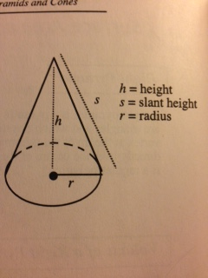
This week I learned that when you are trying to find the surface area or volume of a pyramid or a cone there are two heights in which you have to figure out which one to use. This depends whether you are trying to find the surface area or the volume of the shape. For volume, you will have to use the vertical height. The vertical height is a line running from the point of the cone or pyramid that runs directly down to the middle of the base of the shape. For surface area, you have to use the slant height. The slant height is a line that runs from the point of the shape down along the face(s) to the center of the side(s).

