Measurement Lesson #4: Conversion within the SI System
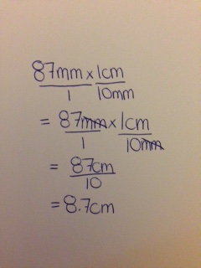
I learned how to convert within metric units using unit analysis. If you were trying to convert millimetres to centimetres you would have to multiply your given millimetres by your conversion factor (in this case centimetres). For example, you can convert 87mm to cm like this:

I took 87 mm and multiplied it by 1cm over 10mm as there are 10mm in a cm. I put 10mm in the denominator so that the millimetres would cancel out in the equation and I would be left with cm which is what I was trying to find. After multiplying across, you are left with 87cm over 10. Divide the numerator by the denominator and it gives you 8.7cm.

