French Revolution Essay
During the 1700’s, France was having major issues that had to be changed. The government was inefficient, there were many economic problems, taxes were imposed only on the third estate, and the government was in debt and bankrupt by 1788. There are many components to the French Revolution but a few stand out the most. The National Assembly and Tennis Court Oath, the March on Versailles, and the Reign of Terror and Committee of Public Safety are three very significant components of the revolution.
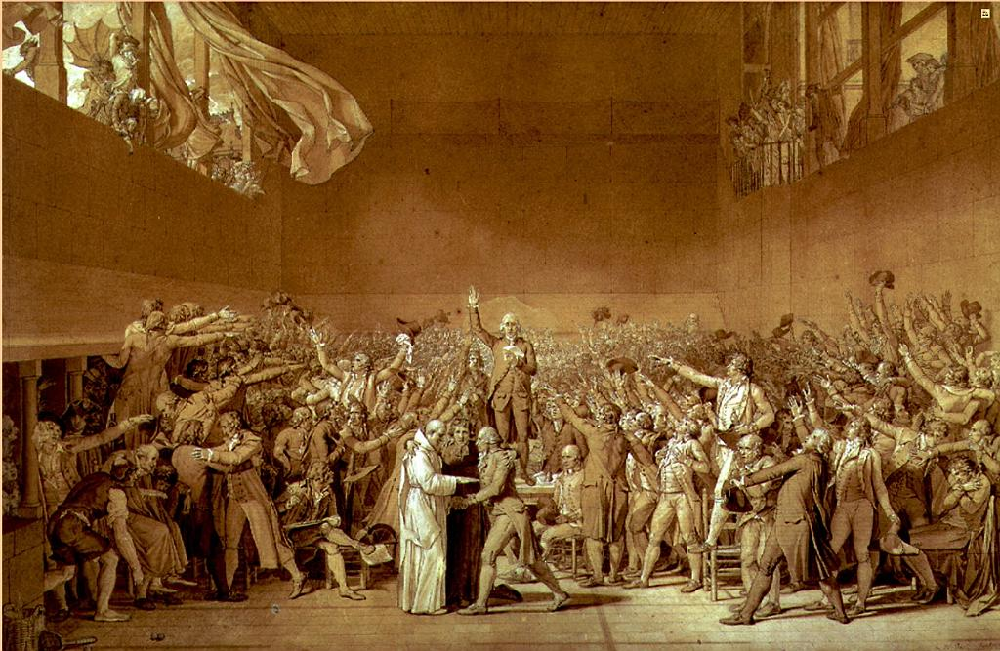
The National Assembly and Tennis Court Oath was a beneficial component and it changed the course of the revolution. It started with the third estate declaring they would form a completely new government and this was the first step towards the revolution. Their goal was to create a new constitution for France. In response to this, King Louis XVI locked them out of the meeting rooms. They then took an oath, a pledge that they were to keep meeting until a new government was formed. King Louis was forced to order first and second estates to join the National Assembly. A painting of a meeting taken place in an indoor tennis court (handball court) displays members of the third estate raising their hands and praising to the speaker in the middle. This event over anything, was an indication the people of France controlled the government.
Meeting held in an indoor court. https://www.mtholyoke.edu/courses/rschwart/hist151/French%20Revolution%20II/album/slides/Oath_Tennis_Court.html
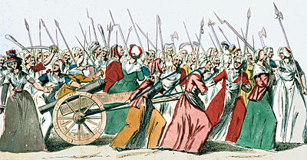
The event known as the March on Versailles was both a violent and memorable component. A group of women were exhausted with waiting for government to deal with the food crisis and this was the start of a major event. A young woman entered the marketplace and began beating a drum as other women began to gather carrying weapons such as kitchen knives. The women then marched to Versailles to greet t he king directly. They were joined by hundreds of women and men, also looking for a change. When they had reached Versailles, a small group of women were allowed to speak to the king. The others got impatient and attacked the National Assembly and stormed the palace. The king did not choose to fight back as this would have looked bad on him and there was a chance he could’ve lost. This was a key component because it brought men and women together in an attempt of change.
Women march to Versailles with weapons determined to see the king.
https://en.wikipedia.org/wiki/Women%27s_March_on_Versailles
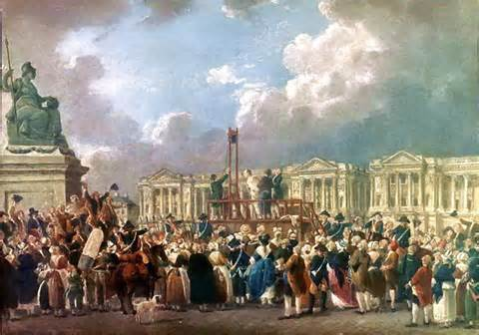
The Reign of Terror is what most people would say had the greatest impact or effect on the revolution. This impact is neither good nor bad because they suffered many losses to achieve what they wanted. The national convention declared France a republic. More moderate members of the government lost the struggle for power with the Jacobins and the Sans-Culottes. They were now considered to be the enemies of the revolution. All Girondists were arrested and imprisoned. There were no restraints on the power of the Jacobins and no one to speak against them. From 1793 to 1794, government was controlled by the Committee of Public Safety. This time period became known as the Reign of Terror. Led by Robespierre, the Committee passed a number of harsh laws intended to intimidate or eliminate anyone who disagreed with them. Thousands were killed in this by guillotine.
Execution of citizens by guillotine.
http://sheg.stanford.edu/reign-of-terror
The three components that had a major impact on the course of the French Revolution were, the National Assembly and Tennis Court Oath, the March on Versailles, and the Reign of Terror and Committee of Public Safety. This revolution had a lasting effect on France and influenced many others to follow.

