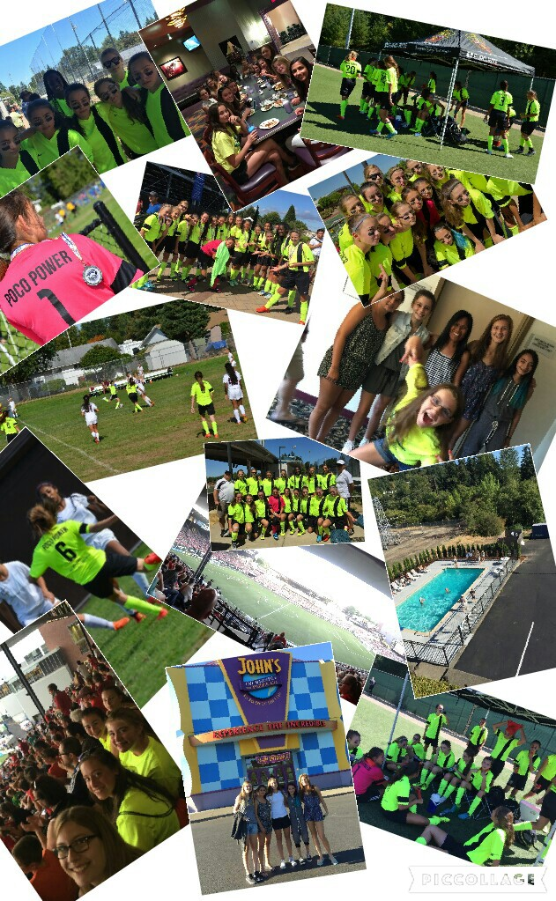

Our Trip to Portland

In the summer of 2015 my soccer team, Poco Power, went to Portland, Oregon for a soccer tournament. It was a five hour painfully boring car ride, even with my iPod for music and cell phone games to amuse me. Amongst the soccer games, we also had fun at the outlet mall, the pool, and John’s Incredible Pizza Co. The outlet mall was great because of the dollar exchange and no tax in Portland, which allowed me to buy plenty of items. The pizza restaurant/arcade was awesome because of the food and games being in the same place. This place was huge with many rooms, each one having different music and decoration. There were tables upon tables of yummy food and we kept on piling our plates. While playing soccer it was like an electric blanket wrapped around us. After every game we would jump in the pool for hours to cool down and have fun as a team. Our team made it to the final match for the trophy and the winning title but we lost and got second which was both disappointing and pleasing at the same time. All in all we had a wonderful weekend and grew stronger as a team.

