Zobaida/ Blk D/ Foods 10/ Sem 2
Breakfast:
Avocado Toast with Creamy Soft Scrambled Egg
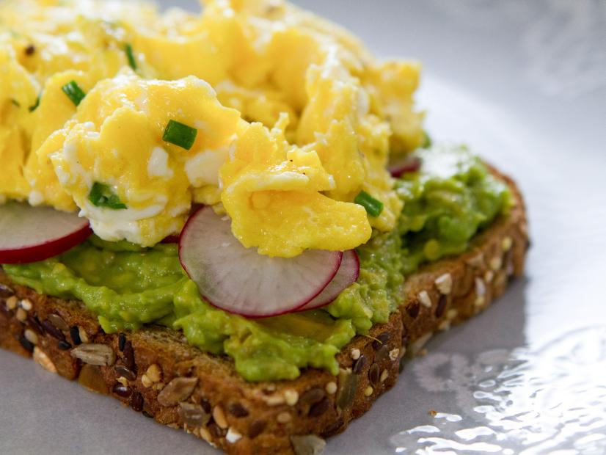
This is a healthy avocado, radish, and scrambled egg toast with chopped chives on top.
right click here and open hyperlink to view the recipe on the website.

Lunch:
Egg Omelette
This omelette with tomatoes inside and garnishes on top is something nice to eat as a lunch. This is an easy to make recipe in 5 minutes.
right click here and open hyperlink to view the recipe on the website.

Dinner:
Garden Veggie Egg Bake
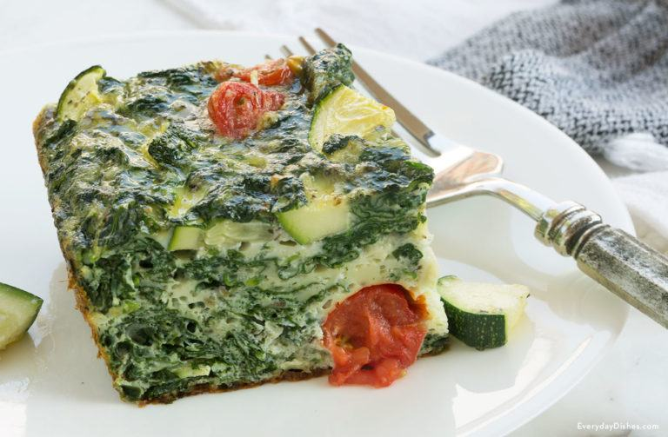
This garden veggie egg bake has so many vegetables in it to make it healthy and is a great meal for dinner that you can make in 75 minutes.
right click here and open hyperlink to view the recipe on the website.

