_{Page 1}
- Use digital images (IN PICTURES ONLY) to create a collage illustrating the future lifestyle you’d like for yourself at 25-30 years old.
  - Include: type of transportation, type of house and where it’ll be, family/spouse, pets, travel, things you’ll do in your spare time, etc.
  - If there are items on the list above that you don’t want (family/pets/travel/etc.) then you don’t need to include them, but make sure you demonstrate all aspects you want in your future life.
Page 2
- Summarize in a few sentences what your future lifestyle might be.
  - What type of things will you do? What will you do when you go out?
  - What will a typical day look like in your life?
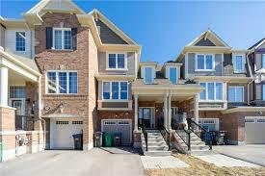
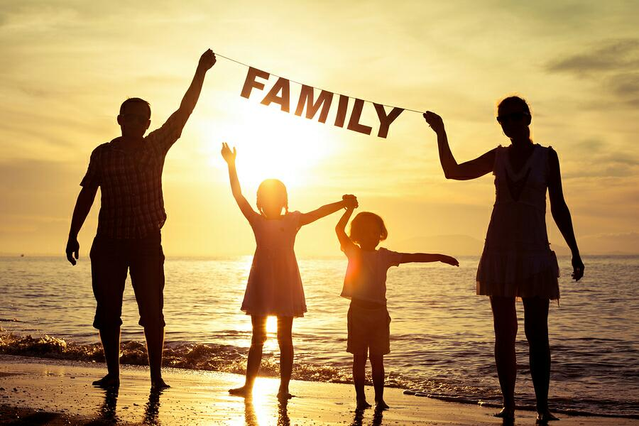
  - Overall, do you want to live a life of luxury, or regular every day living, or simple with no extras, or…?

- List your career’s annual income.

- List the price to purchase each item in your collage, or approximately what it would cost for it
  - Average cost of a wedding is about 30,000 dallors
  - Average annual cost of a child 233,610
  - Cost of a car/bike/annual transit pass depending on what you chose 5,000
  - Etc.

