**SMART GOAL: Education/Career**

(Specific, Measurable, Achievable, Realistic, Timely)

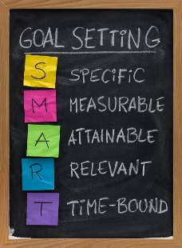 **GOAL STATEMENT:**

I want to be a math teacher who can help students because I am interested in math and I like to help other people.

**WHAT DO I NEED TO REACH THIS GOAL? (The steps you**

**must take in order, and the date you wish the step to be**

**completed by.)**

I will review math 10 what I finished to learn last semester for an hour for two days and prepare for precalculus 11 for a day. I watch ted for 30 minutes every day and practice to speech reading the transcript and record it. Also, I am going to take AP calculus exam two years later, so I need to study on it. Watching videos to teach AP calculus every Saturday and write the words that I do not know and memorize maximum 50 words for 30 minutes.

**HOW ARE YOU GOING TO MEASURE THE PROGRESS TOWARDS**

**YOUR GOAL?**

I am going to find and take the practice test of AP calculus test, and I will listen to the recording speech.

**OBSTACLES YOU MIGHT SOLUTIONS**

**FACE**

I must think again why I wanted to do and get the job. Remind myself what I really want to do.

My English skills are weaker than other Canadian so I will face the high wall of English one time, or the time when I started to lost the interest in math and the limit of my other skills of the study.

**WHO ARE YOU GOING TO SHARE YOUR GOAL WITH?**

It is the most significant goal in my life to me now so I need to share it my family. My cousin and I have the similar goal so she could emphasize the reason and she would help me a lot.

**HOW WILL YOU CELEBRATE YOUR GOAL?**

I wanted to hang out with my friend who I could not meet for studies.

**NEVER GIVE UP!**