My favorite place
Where is this place?
I think you know this place easily that I like if I tell you about it.
There is quietly place, but there is even unquietly place for children. 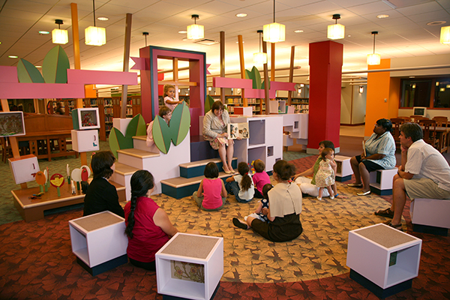
http://www.architectureisfun.com/evanston-public-library-childrens-library/

A lot of people who want to read books or other writing, or want to focus studies visit this place.
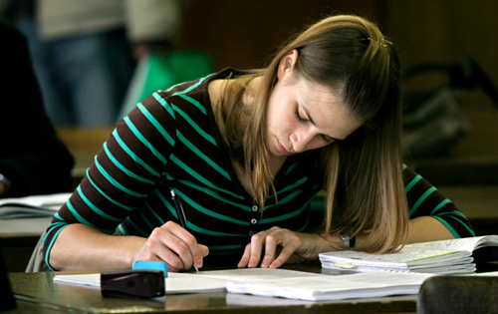
http://www.lawstudentatlast.com/study-study-and-more-study/
This place is even in Riverside, or the place that is the closest from the school is you can visit if you walk for 20 minutes from Riverside.
I think you could already expect about this place.
This place is a library.
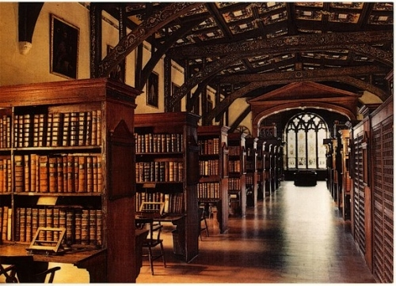
http://favim.ru/image/8655/
I enjoy to go to Terry Fox Library with my friend. 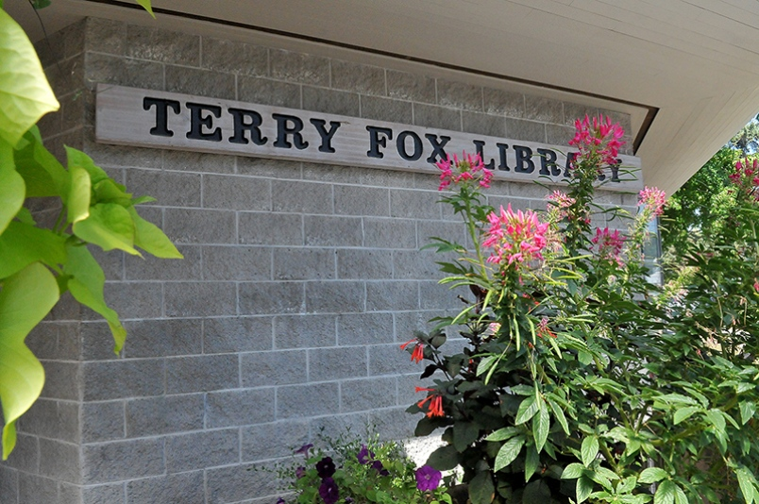
http://www.tricitynews.com/lifestyles/books-plus-tech-at-local-libraries-1.2037620
I need to practise about English, reading library books helps my English study.
Also there is quiet, it is easy to focus doing something, so if I have important assignments, I usually go there.
If I go back to Korea, I really want to go to Korean library. 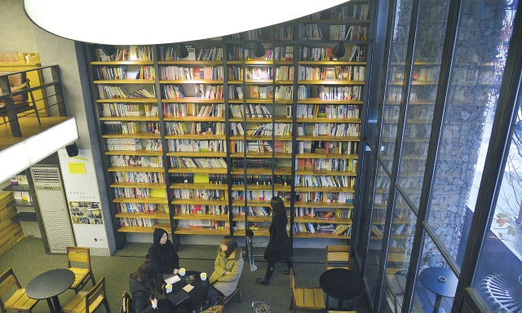
http://nwww.koreaherald.com/view.php?ud=20130125000784
I regret about I didn’t read many Korean books and other translated English books that are too difficult to read for me.

