
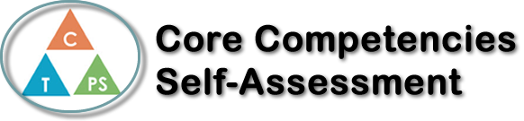
Name: Yosei Ishida | Date: Nov 9th

  How does the artifact you selected demonstrate strengths & growth in the communication competency?  In what ways might you further develop your communication competency? | Self-Reflection  Describe how the artifact you selected shows your strengths & growth in specific core competencies. The prompt questions on the left - or other self-assessment activities you may have done - may guide your reflection process.  Communication  There were many group works and I got many opportunity to talk with someone.  When I stack on some of the questions, I could ask someone about this, and I could solve that. When I write the test, I remind myself what I learned from another student and teacher.  And I also could share my opinion to group. When we were working on skills check, sometimes another member wandering about some question that I could solve. So I could helped them.  Most important thing that I learned in this pre-calculus class was helping each other. Especially, before we do online learning, there was no teams, and no channel for asking questions. However, the online class started and the visualization by Teams of classmates helping each other made me feel that helping each other is important.  Moreover, When I was doing remote learning, I summarized what I learn from last class in order to explain to someone who in need. And I prepared for the next class.  When I prepare for the test, I reviewed work book, and I worked on question that I had not done. I solved it by asking someone what I didn't understand before the day of the test.  First thing do I need to do to improve my communication skill is definitely learning English vocabulary. Likewise, I felt it was important not to miss the opportunity to talk to people more and exchange ideas.


How does the artifact you selected demonstrate strengths & growth in the thinking competencies?

In what ways might you further develop your thinking competencies?


How does the artifact you selected demonstrate strengths & growth in the personal & social competencies?

In what ways might you further develop your personal & social competencies?

Publish Your Self Assessment
You will now attach and/or embed your self-assessment to the bottom of the blog post with the artifact you have chosen. You may choose to make this post private or public. After placing your artifact on a blog post, follow the instructions below.
- Categories - Self-Assessment
- Tags - Now tag your post using the tag that corresponds to the competency that you have written about. You can choose more than one. Please use lower case letters and be exact.
  - #creativethinkingcc
  - #communicationcc
  - #criticalthinkingcc
  - #socialresponsibilitycc
  - #personalidentitycc
  - #personalawarenesscc
- Use the Add Document button located at the top of your post page and embed your self-assessment at the bottom of your blog post.
- Publish

