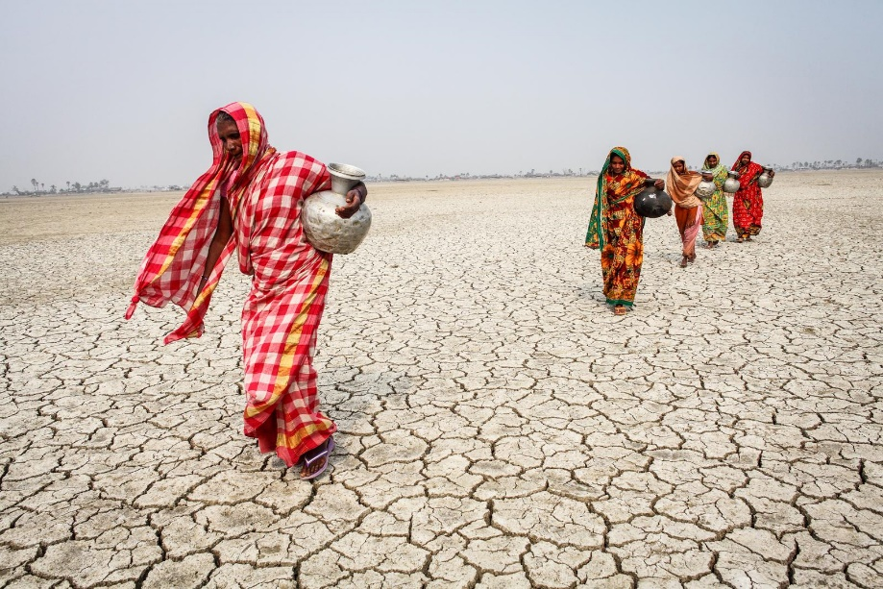
https://www.climatevisuals.org/images?f%5B0%5D=theme%3AImpacts&id=1219
Location: Bramanbaria
Water stress and drought is a major impact of climate change. In the picture, there are no crops grow, the land is dry, the persons in the picture are going to get water, but its too far.
Data: 