- Fire
Grease Fires in the Kitchen
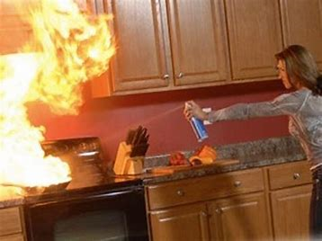
Turn off the burner and leave the pan exactly where it is so that it can cool.
Oven, Microwave, and Electrical Fires
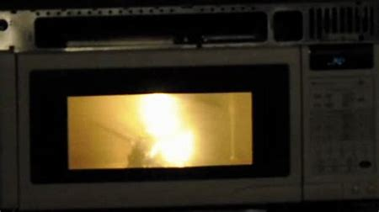
Close the microwave door and keep it closed. Turn the microwave off and unplug it.
- Burns/Scalds (i.e. how to treat)
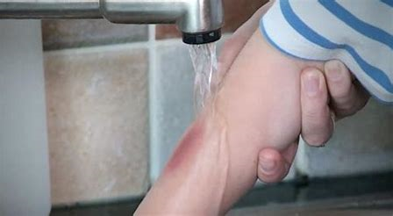
Apply a cold compress/water for 20 minutes.
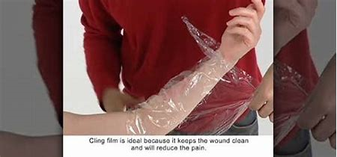
If unsure, seek medical assistance.
- Chemicals
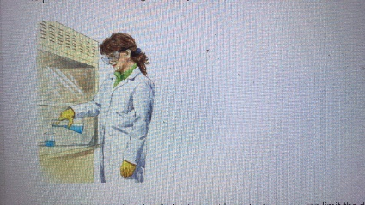
wear protective goggles whenever working with chemicals.
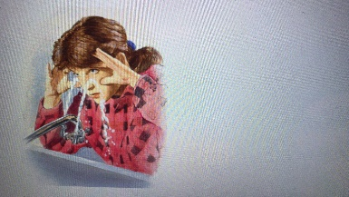
the most important way you can limit the damage is to start flushing the eye with water immediately.
- Slips/Trips/Falls (i.e. how to prevent)
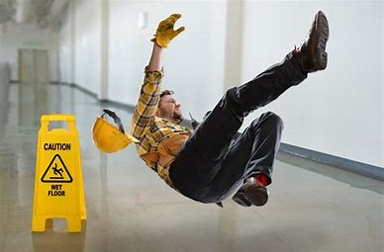
Clean up spills immediately. If a spill can’t be cleaned up right away, place “wet floor” warning
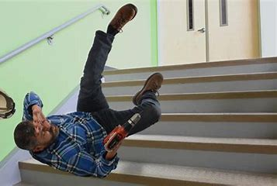
Keep filing cabinets and desk drawers shut when not in use.
- Cuts (i.e. how to prevent/how to treat)
Stop bleeding by pressing a clean, soft cloth against the wound for a few minutes
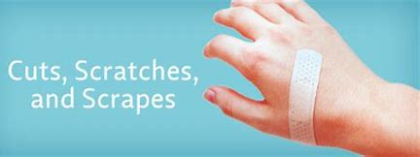
Clean the wound.
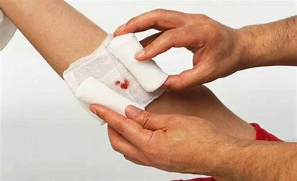
- Heavy Lifting (i.e. of a bag of flour)
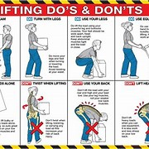
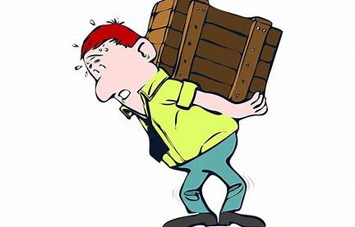
Though the arms suffer the most obvious strains while lifting, a significant amount of stress is put on the back as well.
- How to Prevent Food Poisoning
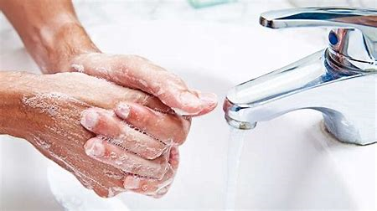
Carefully wash your hands often, and always before cooking or cleaning. Always wash them again after touching raw meat.
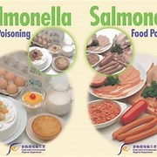
DO NOT place cooked meat or fish back onto the same plate or container that held the raw meat, unless the container has been completely washed.
- Waste Management
Please make smart choices about what you buy and how you dispose and it will go a long way.
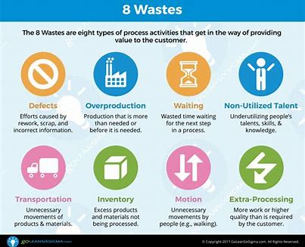
Avoid individually wrapped items and snack packs.
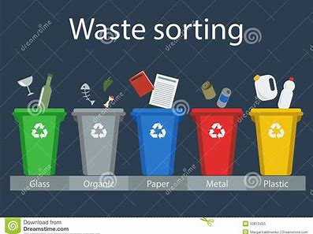
- Personal Hygiene
Good personal hygiene is one of the most effective ways to protect ourselves and others from many illnesses, such as gastroenteritis.
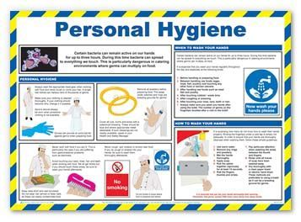
Wash your hands regularly, especially before preparing or eating food and after going to the toilet.
