David Dong
Recipe One
Seafood Spaghetti
Ingredients：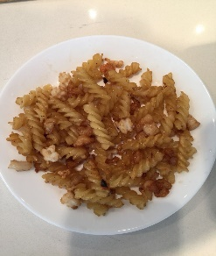
50g spaghetti,
small amounts of shelled fresh shrimps,
small amount of squid,
small amount of Japanese scallop,
10ml cooking oil,
5ml cooking wine,
salt,
chicken power
black pepper
Procedure:
- Clean the shelled fresh shrimps, squid and Japanese scallop and drain off water.
- Fry them with cooking oil and add some cooking wine.
- Cool them and cut into small pieces.
- At the same time, boil the spaghetti for ten minutes.
- Fry the seafood and cooked spaghetti again and add salt and chicken powder and black pepper.
- Seafood Spaghetti is ready.

Recipe Two
Jiaozi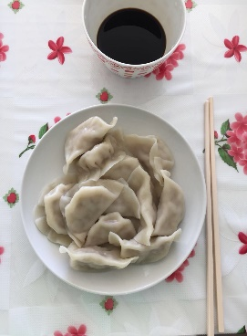
Ingredients:
50 pieces of dumpling wrappers,
400 g white gourd,
200g minced meat
5ml cooking oil
5ml cooking wine
Salt
Chicken powder
Procedure:
- Add cooking wine into the minced meat and stir them.
- Peel the white gourd and cut it into big pieces and slice it.
- Add some salt into sliced white gourd and then drain off the salty water.
- Stir the meat and white gourd, add salt, chicken powder, cooking oil.
- Put fillings onto the dumpling wrapper and make jiaozi.

Recipe Three
Omelette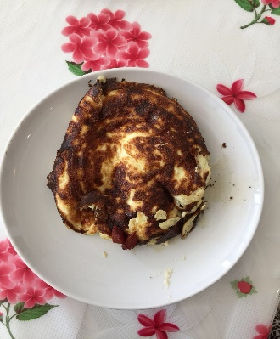
Ingredients:
One slice of pepper
Two eggs
Two pieces of asparagus
Bacon
5ml milk
5ml cooking oil
Salt
Chicken powder
Procedure:
- Clean the asparagus and pepper and cut into very small pieces.
- Cut the bacon into small pieces
- Fry them with cooking oil.
- Add milk into the eggs and stir it and fry it onto the pan.
- Put the fillings onto the egg and wrap it.
- Omelette is ready.

