TED Talk or Rant Project Organizer
Part A:
- What innovations or new systems made the Agricultural Revolution possible and what were their effects? In what ways is it still present today? How is it different today? (Crossroads – Chapter 7 – pg 231-234)
Innovation or System | Effects in the 1700s | Presence Today (similarities) | Differences Today
Enclosure | The enclosure farms allowed people to use machines on the crops. It also increased the farming land so more crops could be planted. | We still use enclosed farms to grow the crops. | The farms are bigger and we use mechanized machines.
Cash crops | Because of the enclosure farms, more food was being grown. As a result, farmers started selling the extra crops they grew and turned it into a business. | Farmers still sell their extra crops to earn money. | Farmers now use artificial fertilizers to make the fruits and vegetables grow faster
Seed drill | The seed drill did three things at the same time. It plowed the ground, threw the seeds, and covered it up. Many farmers lost their jobs because the seed drill did the work more efficiently and quickly. So most of the farmers went to the city. | The seed drill still plows the ground, throws the seeds, and covers it up. | The seed drill is now way bigger and mechanized
Crop rotation | The crop rotation made it so no land was being wasted by having nothing grow there. | We still put nitrogen in the soil so crops can grow in the field. (Using plants that put nitrogen in the soil or fertilizers). | People use artificial fertilizers to put nitrogen in the soil.
Breeding | Animals were bred to be the best at one thing. For example, one animal is bred only for the milk. Another animal is bred for only the meat. | We still have animals that are only for the milk and animals only for the meat. | We now feed them antibiotics to make their meat or milk taste better.

- How did the Agricultural Revolution pave the way for the Industrial Revolution? (Crossroads – Chapter 7 – pg 235)
All the small farmers sold their land because they couldn’t afford new and better animals and plants. After they sold their land, they went to the city to find a job and that help create and support the industrial revolution.

- How has the Agricultural Revolution impacted us today?
Benefits | Drawbacks
- It allowed us to make new technology  - it allowed us to progress and understand about the world  - It allowed people to do something else instead of farming and gathering. | - Overpopulation  - We used a lot of the materials in the environment  - We are now causing global warming because of the factories.
- Http://www.answers.com/q/how_did_the_agricultural_revolution_affect_the_industrial_revolution#slide=1 | - https://www.reference.com/business-finance/advantages-disadvantages-agriculture-8dc0bd7030ea9d9f

Part B:
- What are the major innovations or systems that were new to the Industrial Revolution and what were their effects? (Crossroads – Chapter 7 – pg 236-244) In what ways is it still present today? How is it different today?
Innovation or System | Effects | Presence Today (similarities) | Differences Today
Steam and coal | People burned coal for heat. When the steam engine was made, it used coal as fuel. People use coal to reach higher temperatures so they can smelt metals. | We are still using coal as fuel for our power sources. We still use coal to produce steel. | We use coal for electricity. We don’t use coal to heat our houses.
Iron | People could now make more advance things like iron pots, iron pans, iron wheels, iron and brass steam engines. With carbon and iron, people made steel. People also used steel to support structures. | We still use steel for structures. We also still use iron/steel for everyday items (pans, chairs, desks, pots, wheels). | We now use iron/steel for most of our things. We use most of our iron to make steel.
Textiles | The new technology allowed the steps to make fabric, faster. The steps are clean finer, make the thread, and weave the threads into fabric. Because of the new technology, the demand for cotton increased. | We still use the machines to make fabric so we can make clothing faster. | Now we have many different styles of clothing instead of one.
Transportation | The new steam engine allowed trains to run and get to places. They used coal as fuel to created the steam and used iron for the train tracts | We still use railroad tracts and trains to ship items. We also still use steam engines in the trains. | Now we have trains that use electricity instead of using coal. We also have cars now.

- Create a flow chart or mind map that shows how coal, steam power, iron, textile production, factories and new modes of transportation were all connected (hint: start with coal). Explain the connections.
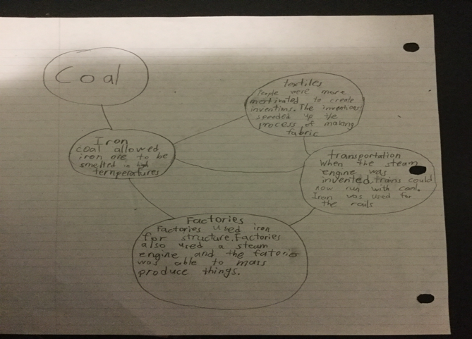

- How have the innovations of the Industrial Revolution impacted us today?
Benefits | Drawbacks
- In the industrial revolution, people were more educated and motivated to create inventions.  - The industrial revolution helped us get the transport we now have today.  - It helped us get the materials and metals we now use today. | - The factories caused a lot of pollution.  - Burning fossil fuels released a lot of carbon dioxide into the air.  - Global warming.  - We are throwing away a lot of materials and ruining the environment
- http://www.ecology.com/2011/09/18/ecological-impact-industrial-revolution/  - http://futureofworking.com/8-biggest-pros-and-cons-of-industrial-revolution/ | - http://www.ecology.com/2011/09/18/ecological-impact-industrial-revolution/  - http://futureofworking.com/8-biggest-pros-and-cons-of-industrial-revolution/

Part C:
- What are the major societal changes that were new to the Industrial Revolution and what were their effects/importance? (Crossroads – Chapter 7 – pg 245-254) In what ways is it still present today? How is it different today?
Innovation or System | Effects/importance | Presence Today (similarities) | Differences Today
laissez faire | Laissez-faire is when the government doesn’t interfere with trades, price and factories. This allowed the business owners to profit a lot. | We still let laissez-faire control the factories and market, but not completely. | The government helps the homeless people by giving them some money so laissez fair doesn’t completely ruin them.
workers | The workers were treated unfairly. They were overworked and tired most of the time. The factory owners payed low wages. The workers had to work as long as 12 to 16 hours. Most of the workers got sick because of the pollution in the air. Sometimes the owners make them working extra hours. | Some business owners still make their employees work extra hours for 10 hours in total. | Today, there is a limit of how much the company owner can make you work. Working in a factor or for a company is much more safer.
Rights | The people didn’t get much rights in the factory. They were punished if they weren’t working hard. There was also a fee for talking to other workers, not being at their station, and whistling. Women also were paid less in the factories. | Some other countries still have punish the people who don’t work as hard. They might also pay them very poorly. Women are still paid a little bit less than men. | In our country, the people who work in a factor or for a company, they get health benefits. They also don’t punish people who don’t work very hard.
Child labour | Kids were employed in factories because the factory owners saw them as useful and their labour were cheap.  Many of the children was paid very little and were beaten. | In other countries, they still might have child labour because it was cheap labour. | We don’t have child labour in our country because we know it’s wrong for children to be working in factories. Instead kids go to school and they learn so they can get a job later on.
Class | The upper class is placed apart from the rest of the British people. They knew each other by personally or reputation. The middle class is for the people who worked in the professions, doctor, engineer, or a lawyer. The lower class had people who worked in the trades or in a factory. | We still kind of have classes. The rich people and poor people. | Today we have different people earning difference amounts of money.

- How have the societal changes of the Industrial Revolution impacted us today?
Benefits | Drawbacks
- People learned that factories was the best way to produce items because all the steps was in one roof.  - We learned that overworking the people who worked at the factories was wrong and limited it to 8 hours  - We learned using children for cheap labour was a wrong thing to do | - We still have pollution from the factories  - Companies are still trying to profit a lot from giving employees minimum wage
- http://industrialrevolution.sea.ca/impact.html  - https://www.reference.com/history/did-industrial-revolution-affect-society-81e845ce5bea44e9 | - http://industrialrevolution.sea.ca/impact.html

Part D:
- How did Britain react to the new changes of the Industrial Revolution? Crossroads Chapter 7pg 255-259.
Reaction | Importance | Presence Today (similarities) | Differences Today
Poor Law | The poor law introduced workhouses. The workhouse was a place where you would do work and get paid for it from the government. The government also raised the taxes for high class and middle class people and lowered taxes for the low class. | The people who have more money has to pay more taxes than the people who don’t have a lot of money. | Instead of workhouses, the government gives the homeless a little bit of money to help them get a job.
Social reformers | People stopped child labour and kids went to schools instead. People donated to the schools and the schools gave children lessons and food. | Kids go to school to learn instead of working to get money. | Hiring children is illegal. Schools now teach children more focused things like English, math, science, etc…
Factory acts | In 1802, it was illegal for children to work more than 12 hours straight.  In 1819, it was illegal to hire a child that was under 9 years of age in the textile industry.  In 1824, workers’ associations became legal.  Eventually, there was a maximum of 12 hours of work for a man including an hour lunch break. | There is still a maximum amount of hours you can work. Unison are still allowed (in Canada). | Now you can only work for 8 hours and anything over that is overtime.
Abolition of slavery | People used slaves to produce sugar, molasses, rum, and tobacco easily.  Then people slowly formed up and tried to end slavery. In 1793, Canada stopped slavery as well. Eventually they made slavery illegal in Britain. “All men are created equal” | Slavery is still illegal in most countries. We still think everyone is equal and has human rights. | We now use mostly machines to make things instead of people/slaves.

- How have Britain’s reactions to the Industrial Revolution impacted us today?
Benefits | Drawbacks
- We learned that slavery is a bad thing and made it illegal  - We learned that kids should be learning instead of working  - We capped the working time to 8 hours a day | - Most business give only minimum wage  - Higher up business owners get more money then the employees
- http://webs.bcp.org/sites/vcleary/ModernWorldHistoryTextbook/IndustrialRevolution/IREffects.html | - http://webs.bcp.org/sites/vcleary/ModernWorldHistoryTextbook/IndustrialRevolution/IREffects.html

