
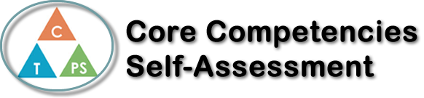
Name: Tryston Hickson | Date:

  How does the artifact you selected demonstrate strengths & growth in the communication competency?  In what ways might you further develop your communication competency? | Self-Reflection  Describe how the artifact you selected shows your strengths & growth in specific core competencies. The prompt questions on the left - or other self-assessment activities you may have done - may guide your reflection process.  In science 9 I have been doing pretty well. I enjoy my class and the labs we do, and I feel engaged in what I am being taught. I have struggled a little bit I did not do very good on a unit test but I seem to understand a little more about atoms and their cell structures. I am enjoying my classmates. They encourage me to get better and they keep me on task. Science 9 has been quite a jump from science 8. Before this year I have really never looked at a periodic table closely, so far, this whole subject is surrounded by it. The way atoms form and chemical combinations fascinate me. I am very excited to continue my learning and see what I run into next.


How does the artifact you selected demonstrate strengths & growth in the thinking competencies?

In what ways might you further develop your thinking competencies?


How does the artifact you selected demonstrate strengths & growth in the personal & social competencies?

In what ways might you further develop your personal & social competencies?

Publish Your Self Assessment
You will now attach and/or embed your self-assessment to the bottom of the blog post with the artifact you have chosen. You may choose to make this post private or public. After placing your artifact on a blog post, follow the instructions below.
- Categories - Self-Assessment
- Tags - Now tag your post using the tag that corresponds to the competency that you have written about. You can choose more than one. Please use lower case letters and be exact.
  - #creativethinkingcc
  - #communicationcc
  - #criticalthinkingcc
  - #socialresponsibilitycc
  - #personalidentitycc
  - #personalawarenesscc
- Use the Add Document button located at the top of your post page and embed your self-assessment at the bottom of your blog post.
- Publish

