Poem analysis
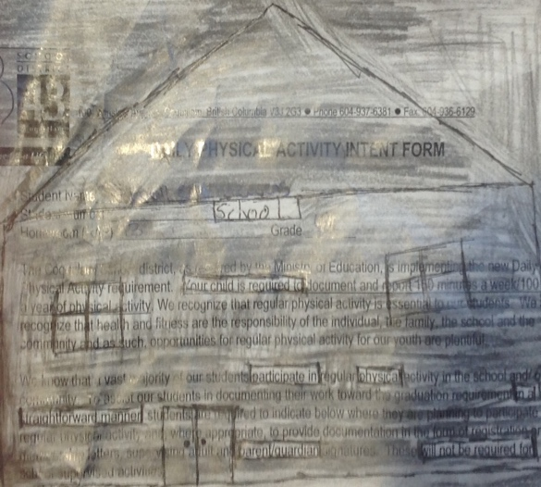
The title of the poem is “The Stranger” written by Gord Downie. The stranger was was about the struggle of residential schools so the child decided to run away. My black out poem was about how they have you working at the school and you can’t have your parents. The thyme of the the stranger is that it shows you that the past wasn’t perfect and that everything can be taking away from you in a instant. My thyme is that they force you to go to this school and live your lives there. Both relate with the thyme that everything can be taking from you in the blink of an eye. These poems are significant cause it show you are past in a way that doesn’t involve textbooks it gives you more visual to understand the topic. Repetition in the words I am a stranger rhyme it’s rhymes the words and rhythm to make it in to a song.

