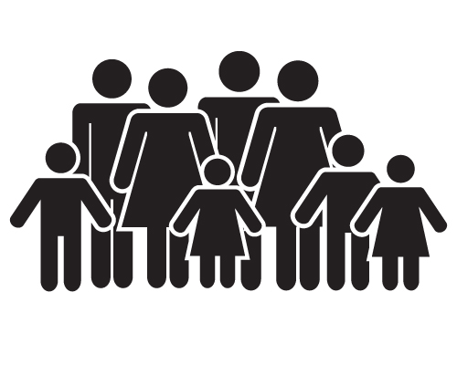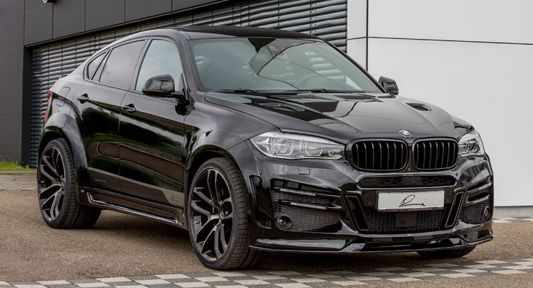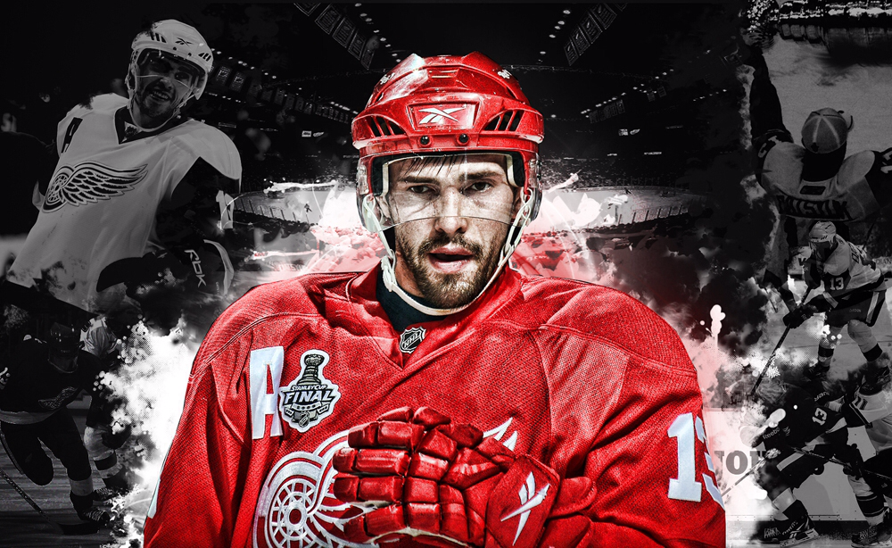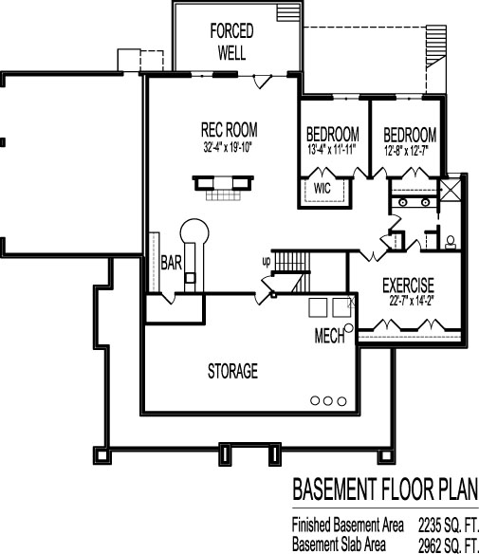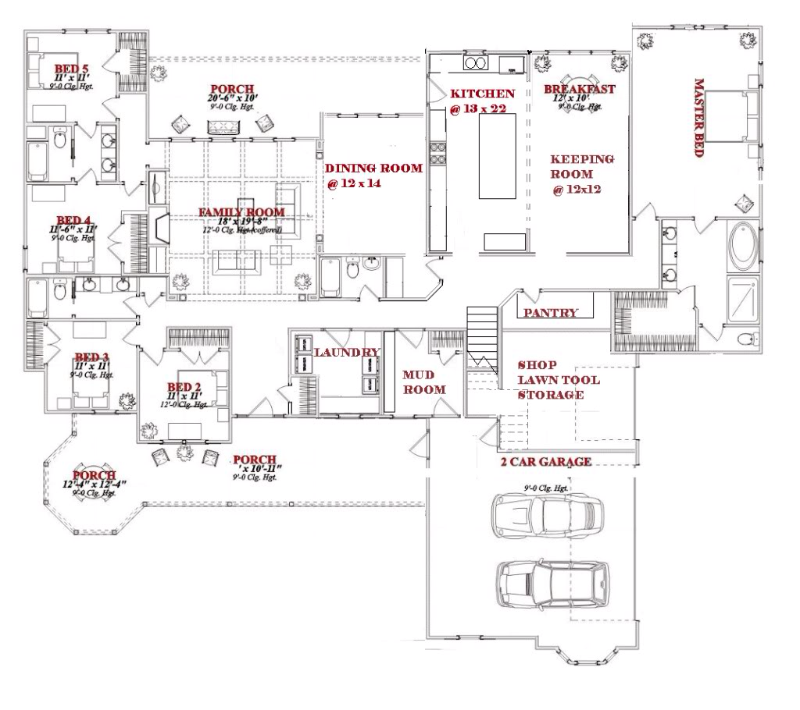

I want to live close to family when I am older

I want to drive a black BMW X6 when I am older

I want to be a pro hockey player and play for the Detroit red wings when I am older

I want a one story hose with a basement to live in when I am older.

Terrell's

Future

Lifestyle