Using Quotes in your essay
For more information on using MLA Works Cited and In-text citations, here is the link to my Edublog with videos that help build and/or summarize what is in this document.
- First, do your Works Cited at the end of the document. Use this citation generator to make your Works Cited. Always double check your formatting as the generator can get it wrong
  - Why do this first?? Because you will use the first word in your Works Cited as your first word in your in-text citation bracket!!
Eg. Works cited:
Rhombus. “8th Fire - Episode 1 - Indigenous in the City.” YouTube, 8 July 2020, www.youtube.com/watch?v=H19__cXhjMY.
In-text citation: (Rhombus 9:52-9:58)

When to use quotes:
- Memorable language - use quotation when the author of your source turns a phrase, sentence, or passage of particularly powerful, vivid, or memorable language.
- Clear and concise language - use quotation when the language in your source is so clear and succinct that any attempt to paraphrase would be ineffective.
- Authoritative language - use quotation to add the authority of experts and prominent figures. Quotations from authoritative sources can be useful in supporting your argument.
- Language for analysis - use quotation to highlight source passages that you will discuss and engage in rhetorical analysis.
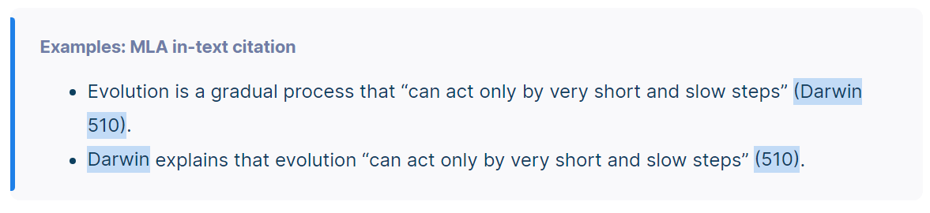
- “Poems”- (Author, line #); (Author, lines #-#) – yes, there is a comma here!!
- Book/”short story” (Author page #); (Author #-#)
- Play, Movie or short film or “TV Show” (Shortened title time stamp)
- TED Talk: https://www.scribbr.com/mla/ted-talk-citation

Notes:
- Integrate quotations into your own writing.
- Do not stand quotations alone -the must always have context. No quote bombs!!
- Provide signal phrases, which include the author’s name and a signal verb. MLA style uses present tense signal verbs, in- text citations, and full source listings on the works-cited list at paper’s end.
  - King writes, “This totem pole is not part of the show, and we need to move it someplace else” (387).
    - Note you don’t put the author’s name in the brackets because you already used it in the signal phrase.

Vary the placement of your signal phrases and use a variety of signal verbs.
- The story ends with a reminder that non-Indigenous Canadians “…remained mildly annoyed that the totem pole continued to take up space and inexplicably irritated by the low, measured pulse…” thereby signalling the continuing racism in this country (King 389).
  - Note you use ellipses… to show you are deleting part of the sentence to make it more concise and relevant to your point.

Great link: https://www.scribbr.com/mla/in-text-citations/

Movies and Documentaries
Citing movies or documentaries is more complicated. This link will help: https://www.scribbr.com/mla/how-to-cite-a-movie

Directions: Follow the rules below to change the quote mechanics into MLA formatted in-text citations.
Add a Works Cited at the end for practice.
Source: Indian Horse by Richard Wagamese

- Rules: If the word just before the quotation is a verb indicating someone uttering the quoted words, use a comma. Examples include the words "says," "said", "states", "asks", "yells”, writes."
Capitalize the first letter of the quote.
Eg. Someone says, "Quotation"(last name page #). Explain relevance.
Firstly, in the novel Indian Horse, Saul is taken away to St. Jerome’s Residential School, where a nun claims. “at St. Jerome’s we work to remove the Indian from our children so that the blessings of the Lord may be evidenced upon them,” (Wagamese, 46-47). Saul was beaten and abused by the priests and nuns, and witnesses other kids killing themselves or going insane by the trauma and racist mistreatment of the kids.
Exception: If the word just before the quotation is “that” then you do NOT have a comma. I call it a “snippet” but some call it a “flow” quote.
Harper Lee shows the growth of the protagonist and the loss of innocence when Scout states that, "I was born good but had grown progressively worse every year” (Lee, page 67).

- Rules: When quoting multiple speakers in less than four lines, put the quote in double quotation marks, then single. Think of the whole quote hugging the little quote
Capitalize the first letter of the quote.
The St. Jerome’s team plays another town team, but when the First Nations kids step on the ice, they are greeted with mockery and because Saul was so small, the other team yelled “the Indian school brought their mascot!” “It’s he a squirt? Nah. He’s a dribble!” (75). This racism makes Saul determined to play better than the white team.

- Rule: If you use a complete sentence to introduce a quotation, use a colon (:) just before the quotation.
Capitalize the quote.
Eg. Complete sentence: "Quotation" (Author’s last name, page #). Explain relevance.
Saul turns to drinking to numb the pain of his hurting “You drink down beyond thinking, beyond emotion. You drink down to where you can’t hear voices anymore, can’t see faces, can’t touch anything, can’t feel” (Wagamese,). The Residential school and the other hockey teams made him feel ashamed of his skin, and he wanted to shrink into nothing and disappear.

- Rule: If you are quoting more than four lines, use block quotations that are indented and no quotation marks. Always begin with a colon and cite the page number at the end.
Saul arrives at St. Jerome’s Indian Residential School after a long journey only to be greeted by a priest,
…and ordered to strip and climb into the tubs of nearly scalding water…the priest made us stand and threw handfuls of delousing powder over us…Then the pair of nuns scrubbed us with stiff-bristled brushes. The soap was harsh. They rubbed us nearly raw. It felt like they were trying to remove more than grime or odour. It felt like they were trying to remove our skin…we sat in the chairs with towels around our shoulders while nuns shaved our hair down to nubby crew-cuts with electric clippers. I watched my long, straight hair land on the floor, and when I looked at the other boy he was crying huge silent tears (Wagamese 44-45).
This is the first sign of the torture and hardship that was to come for Saul; the first sign of unstoppable change.

