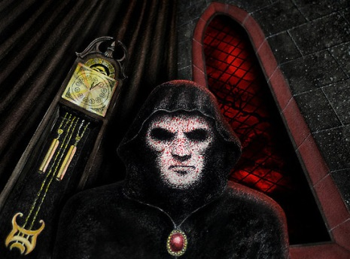
The Masque of the Red Death
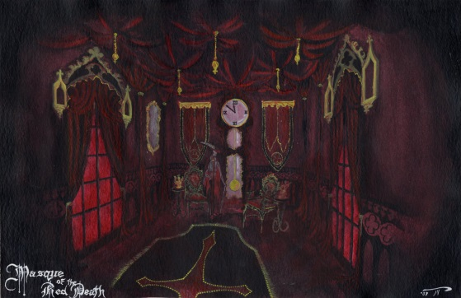
- Vocabulary: Create a “quizlet” https://quizlet.com/ for 20 words from the Vocab List. Find a definition from the internet that matches the sentence offered. Make yourself a quiz. Save the quiz to show me for completion marks. I will create a quiz with my own sentences. You will match them.
2. Prewriting: In a short journal entry, answer one of the following questions with a personal or global connection. I suggest deleting one of the quotes and using this box for your answer.

“Let the outside world take care of itself” is a common attitude today. What does it mean? Give some examples of the excuses people make to avoid thinking of others if it does not affect them. Can you think of any modern day examples where the world is not paying attention to people in need (or state of our environment) because it is not happening to themselves?

Or
Comment on the following quote: “Nearly all men can withstand adversity, but if you want to test a man’s real character, give them power”- Abraham Lincoln.

Background Information: Poe’s story takes place in seven connected but carefully separated rooms. This reminds the reader of the past significance of the number seven. (The history of the world was thought to consist of seven ages, just like an individual’s life had seven stages. The ancient world had seven wonders; there were seven deadly sins with seven virtues.) In the Book of Revelations 7, the angel’s trumpeted the end of the world. Therefore, this story is an ALLEGORY. Why?
Concept focus: symbolism, irony, allegory
Reading Strategies: visualizing, questioning, inferring

During Reading: While reading, make a list of objects that are repeated over and over and seem to be important to the story. These may be symbols. Also, be sure to question and VISUALIZE!
For discussion:
- Which parts create the best imagery? Draw what you see in this story. Be sure to include the most important elements and the colours.
- Why do you think the prince held a ball when the Red Death was killing thousands outside the castle walls?
- What details does Poe use to make the masked figure more and more ominous? Why is the masker “untenanted by any tangible form”?
- What are the three main symbols in this story? What do they mean?
- What is the irony in this story?
- What is the theme of this story?
To answer in writing:
- What is the irony in this story?
- Describe the three main symbols in the story. What are they and what do they represent?
- Why is this story an allegory? Answer in detail.
- What is the theme for this story? What is Poe saying about power and death?
- What elements of Gothic fiction is exhibited in this story?
Reading Response (Post Writing)
One essential question for our Gothic unit is “How does Gothic literature reflect the human condition?” So, how does this story reflect the human condition? Answer in a detailed, but short paragraph. Word count is between 100-150 words with one correct MLA formatted quote. (in text citation)

