Literary Studies and Composition 10- Honours
The aim of Literary Studies and Composition 10 is to provide students with opportunities for personal and intellectual growth through speaking, listening, inquiry, reading, viewing, writing, and representing to make meaning of the world and to prepare them to participate effectively in all aspects of society.
The goals of Literary Studies and Composition 10 is to:
- comprehend and respond to oral and written language critically, creatively, and articulately.
- communicate ideas, information, and feelings critically, creatively, and articulately using various media
- think critically and creatively; reflect on and articulate thinking and learning to be engaged and educated citizens
- question and explore the human condition through inquiry of a variety of texts and genres
- develop a continuously increasing understanding of self and others
- develop an understanding of the Core Competencies through literature and self reflection

The big ideas of English 10:
- The exploration of text and story deepens our understanding of diverse, complex ideas about identity, others and the free world
- People understand text differently depending on their worldviews and perspectives
- The examination of First Peoples cultures and lived experiences through text builds understanding of Canadian responsibilities in relation to Reconciliation
- Texts are socially, culturally, geographically, and historically constructed
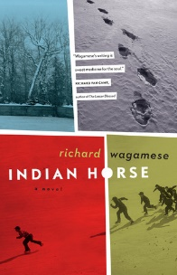
- questioning what we hear, read, and view contributes to our ability to be educated and engaged citizens
- language shapes ideas and influences others

My philosophies:
- “After everything I have done and taught in my life, I realize I … know… nothing.” Professor of Education UBC on his retirement at 75 years old
- We are in this together so let’s learn from each other.
- Learning is more important than mastering. It is the journey that matters.
- A growth mindset is key.
- Be kind to yourself and strike a balance between work and play.

Content
Prose: Short Stories, Novels (Class novel: Indian Horse, Lit Circle: your choice)
Poetry: Traditional (Harlem Renaissance poems), Contemporary, Spoken Word
Writing: Personal Reflections; descriptive, narrative, and synthesis essays; Spoken Word options; creative writing independent project
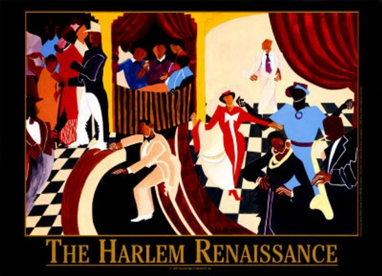
Inquiry: Exploring the human condition through literature and other sources
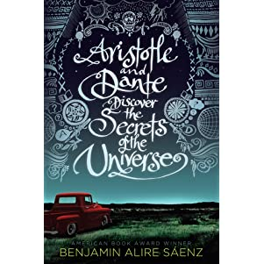
Grammar and Vocabulary: The mechanics of good writing and building sophisticated vocabulary on NoRedInk and other platforms
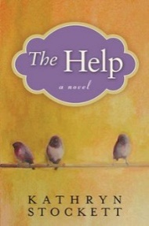
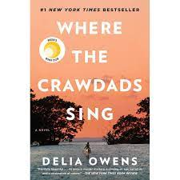
Rough Schedule
- September/October- Class reading of Indian Horse, short stories and poetry about Indigenous experience. Narrative essay.
- October/November- Poetry from the Harlem Renaissance, War poetry and short stories, Spoken Word
- December- Lit Circle
- January- synthesis essay, novel project, final project

Assessment
Assessment will be both Formative (homework checks, informal feedback, suggestions, and conferences) and Summative (to demonstrate your understanding such as tests, projects, essays).
- Essays/projects/tests/assignments are worth 90% of the final mark. I weigh the assignments with points. Eg. Your synthesis essay will be worth 40 marks whereas a short story response may be worth 10 marks.
- Homework completion, blog postings, reflections and essay corrections are worth 10% of your mark.
  - Homework assignments are not always assessed for comprehension BUT you will get marks based on their completion, effort, and punctuality.
    - 3 marks for completion with effort.
    - 2 marks for completion but one day late.
    - 1 mark for little effort OR more than one day late (unless you have asked for an extension)

Materials
Must have access to your Edublog and TEAMS
Must bring everyday:
- Writing utensil
- Electronic device with a charger with a file for all English assignments.
- English texts/books you have been assigned
