English 12
The aim of English Language Arts 12 is to provide students with opportunities for personal and intellectual growth through speaking, listening, reading, viewing, writing, and representing to make meaning of the world and to prepare them to participate effectively in all aspects of society.
The big ideas of English 12:
- The exploration of text and story deepens our understanding of diverse, complex ideas about identity, others and the free world
- People understand text differently depending on their worldviews and perspectives
- The examination of First Peoples cultures and lived experiences through text builds understanding of Canadian responsibilities in relation to Reconciliation
- Texts are socially, culturally, geographically, and historically constructed
- questioning what we hear, read, and view contributes to our ability to be educated and engaged citizens
- language shapes ideas and influences others

My philosophies:
- “After everything I have done and taught in my life, I realize I … know… nothing.” Said my 75 year old UBC Education professor on the eve of his retirement.
- We are in this together so let’s learn from each other.
- Learning is more important than mastering. It is the journey that matters.
- A growth mindset is key.
- Be kind to yourself and strike a balance between work and play.

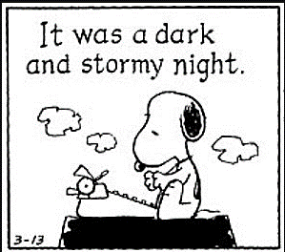
Content
Prose: Gothic Short Stories, Lit Circles, Storytelling
Poetry: Gothic Poetry, Spoken Word, Indigenous Hip Hop
Drama: Frankenstein with the National Theatre
Inquiry: exploring the human experience through literature and media
Writing: Personal reflections and opinion pieces; formal paragraphs in response to literature, informal responses to literature, two essays: synthesis and narrative.
Grammar and Vocabulary: The mechanics of good writing and building sophisticated vocabulary using mentor texts and online sites such as Grammar Bytes and No Red Ink
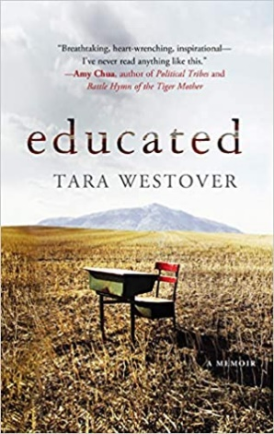

Rough Schedule
September/October- Gothic literature,
October/November- Indigenous Story Telling (Traditional and Contemporary), spoken word
November/December-

Edublog
Look under “Today’s Classes grade 12” to find the link to English 12 daily classes. If you are absent, don’t ask me what you missed, look on the blog and be ready for the daily lesson.

Assessment
Assessment will be both Formative (homework, informal feedback, suggestions, and conferences to help you learn) and Summative (to demonstrate what you have learned such as tests, projects, essays). Assessment will be based on skills, comprehension, depth and insight, and creativity.

- Essays/projects/tests/assignments are worth 90% of the final mark.
- Completion, reflections and essay corrections are worth 10% of your mark. This includes assignments that are not “assessed” per se but are completed to advance your learning. They are completion marks (3-on time with effort, 2-one day late with effort, 1-late and/or minimal effort)

Materials
Must bring everyday:
- Writing utensil (only blue or black pen or pencil) and highlighter
- Electronic device with a charger
- English texts/books you have been assigned
- Access to your TEAMS and Edublog is mandatory

