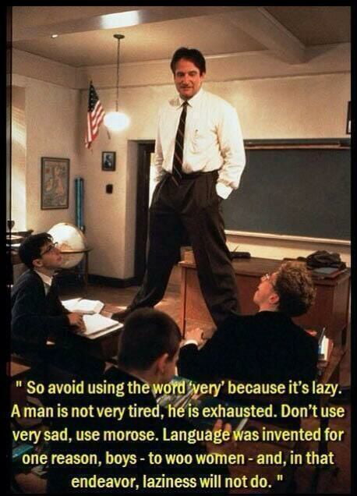
Prose Fiction Terminology
Note: the bolded words are required terms to understand for English class and the final exam
Fill in the blanks with examples from the movie Dead Poet’s Society

Elements of prose fiction
A. Plot: The events of the story or the series of actions that take place in the story are referred to as the plot. Basically, the plot is what happens in the story. Traditionally, it is divided into five parts.
1. Exposition/Introduction: The reader meets the characters and discovers the setting. Reader interest is aroused here. The conflict that drives the story’s action is discovered at the end of the exposition or introduction, with the complication or initiating incident.

2. Rising action: This builds up the story, is the longest part of the story and is a series of steps that lead to the climax. You get more information about conflict and character here.

3. Climax: Here, the reader finds out what happens to the conflict, or how the conflict is resolved. It may not yet be finished, but the reader now has a good understanding of what way it is going to go.

4. Falling action: The plot begins to wrap up in this section of the story which is usually brief.

5. Denouement/Resolution: This part follows quickly after the climax and provides the last pieces of information for the reader. Denouement is French for “unknotting”; you may therefore think of denouement as the unknotting or untangling of the plot. Another word for denouement is conclusion.

B. Characterization – Todd, Neil, Mr. Keating, Charlie, Knox, Mr. Nolan
Character Types
• Protagonist: The main character in the story – usually, but not always, a “good guy”.

• Antagonist: The force against the protagonist. Is usually another character, but not always, especially if the conflict is “person against self”. The antagonist is usually described as “the bad guy”, although that description doesn’t work if the conflict is person against self or person against environment.

• Flat: This is a minor character with one or maybe two sides to the personality.
These characters might not seem very realistic or life-like because so little is known about them.

• Round: These characters are believable and complex people with several sides to their personality. They are lifelike and behave like real people would, if real people were in those same situations

• Dynamic: Also known as a kinetic character, a dynamic character changes in some important way because of plot events. For example, a cruel old man might see the error of his ways and become generous and kind. Or, a gentle girl becomes vicious and angry because of her parents’ divorce.

• Static: These characters are the opposite of dynamic characters. These are people who don’t change in the course of a story. They have the same personality throughout.

• Stock: Also known as stereotypical, these characters are people who are easily recognized as “types”. It wouldn’t matter what story they appear in, they are always the same. For example, the old witch-like woman, the geeky scientist, the airhead, the dumb jock.

C. Conflict: Conflict drives the plot forward and creates interest. There are four different types of conflict: Highlight the correct answer and explain
• Character versus person
• Character versus self
• Character versus environment (nature)
· Character versus society
• Character versus the supernatural/machine

D. Setting: the author may choose to state the setting clearly or leave it to the reader to infer from textual clues (such as weather). There are two parts to a complete setting:
• Emotional Setting (mood or atmosphere throughout the story)

• Physical Setting (time, place, season)
Setting may also be considered as divided into the categories of general (season, town, etc.) and immediate (the actual surroundings in the story/novel).

E. Point of view:

G. Theme: Theme is defined as a main idea or an underlying meaning of a literary work that may be stated directly or indirectly. The plot, conflict, characterization, etc all lead to the message of the story. It is usually inferred as opposed to directly stated.
·Theme statement: The message the author is trying to convey written as a full sentence.

Fiction Devices and Features

Style: Writers use many, many different techniques to attract reader interest and attention or accomplish their literary purpose in short stories, novels, poems and plays. Several such techniques follow here:
• Irony: Strangeness between what might be expected and what actually occurs
- dramatic irony- when the audience knows of a plot event or situation but the characters do not. (eg. We know the killer is behind the door but the character does not)

- verbal irony- speaks something contradictory to what she/he intends to (eg. “Nice weather we are having” yet it is pouring rain)
  - sarcasm is a form of verbal irony but it is meant to mock (eg. “Nice shoes” when really you think they are terrible)

- situational irony- when something is expected does not happen. (eg. An English teacher who cannot spell. A professional hockey player who does not like to skate)
• Satire: A style of writing that has the goal of mocking or scorning an individual, an institution or society as a whole

• Symbol: A symbol has two levels of meaning: a literal level and a figurative level. Objects, characters, events and settings can all be symbolic in that they represent something else beyond themselves.

Inquiry Questions
How does this movie reveal the complexity of the human experience? What are some common conflicts and issues that many other humans share?
What inquiry questions can be generated regarding Relationships and Power from this movie?
Eg. How can one make friends?

