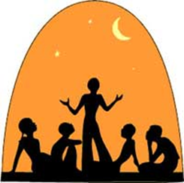

English 12 - The Narrative Essay

What is a Narrative essay?
- Narrative writing tells a story. In essays, the narrative writing could also be considered a reflection, or an exploration of the author's values and insight told as a story. The author may remember his or her past, or a memorable person or event from that past, or even observe the present. Some may call it “Creative Non-fiction”.
- As we discussed earlier, Indigenous People in the America’s relied on oral storytelling to pass down knowledge and to pass the time
- 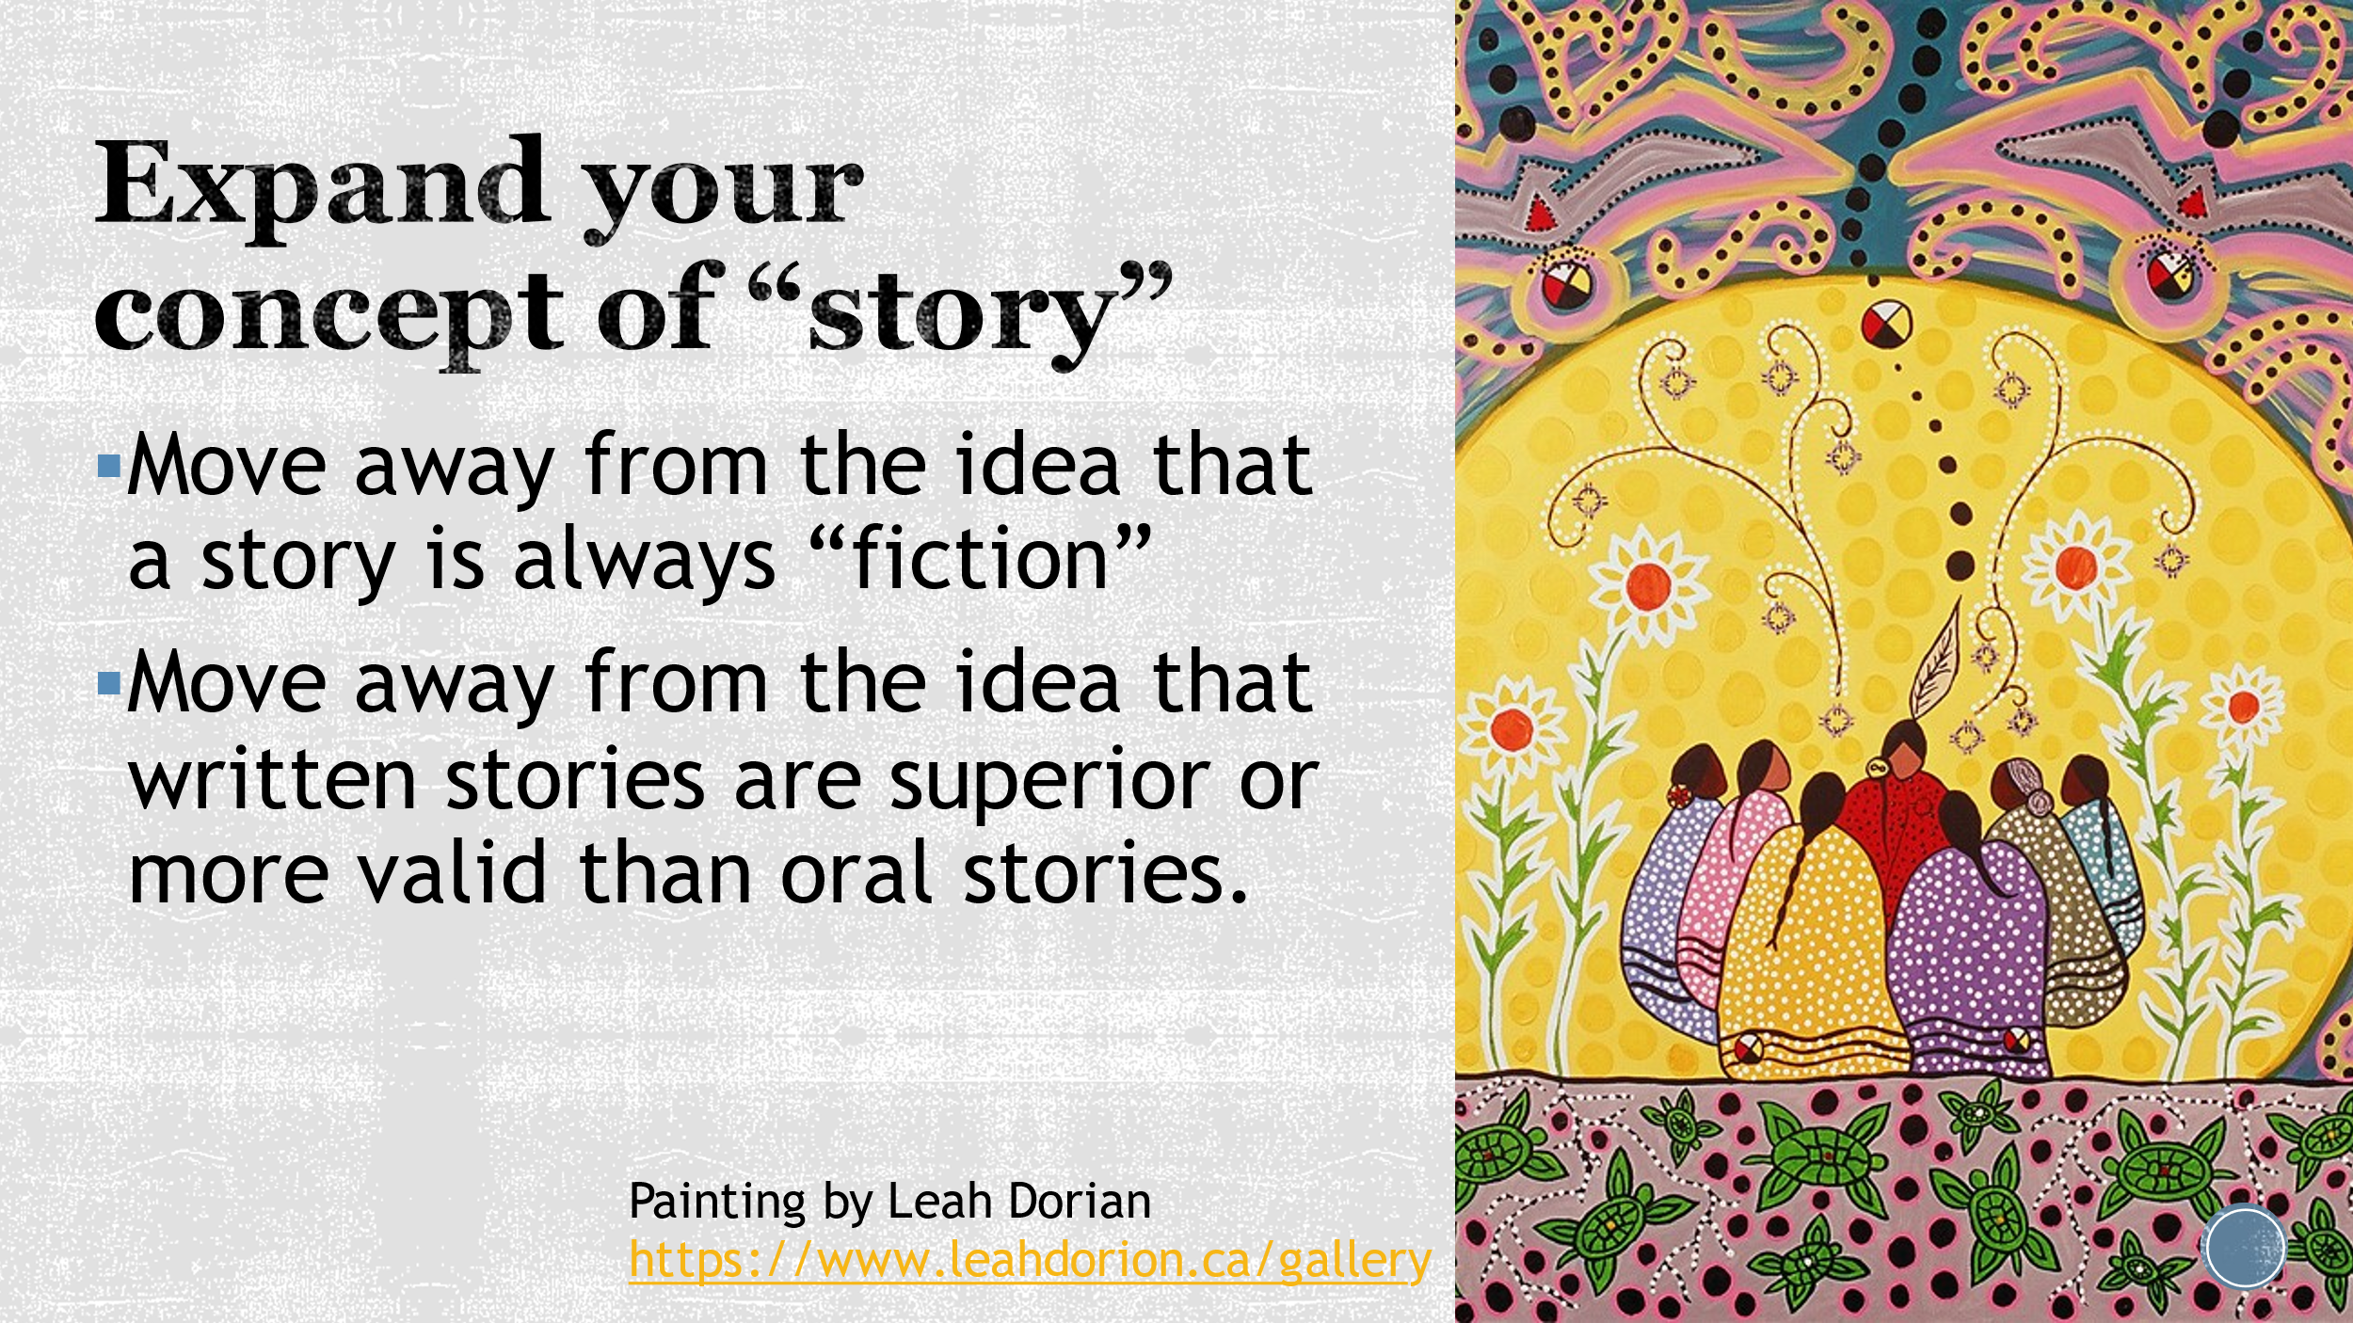

We are going to fuse Western story telling with oral storytelling using the First People’s Principles of Learning.

- When to narrate vs explain (Expository essay):
  - The prompt reminds you of an experience or set of circumstances of your own (experiential)
  - The prompt reminds you of an important aspect of your past, an autobiographical incident that has special meaning (reflective)
  - You have learned from an experience and the best way to show your ideas is through story

- Choose ONE prompt for this essay. This will be your central theme in a narrative from your life:
  - Learning ultimately supports the well being of the self, the family, the community, the land, the spirits, and the ancestors.
  - Learning involves recognizing the consequences of one’s actions
  - Learning involves generational roles and responsibilities
  - Learning requires exploration of one’s identity
  - Learning involves recognizing that some knowledge is sacred and only shared with permission and/or in certain situations.

Basic qualities of a narrative essay:
- A narrative essay is a piece of writing that recreates an experience through time. It follows a logical sequence, so consider the best order to tell it.
  - The Opposite of Loneliness: Begins with lots of personal reflection about school life at college, both the highs and the lows, but ends with an anecdote about walking in a winter snowfall to the administrative building where she has an insight about her life at Yale.

- In addition to telling a story, a narrative essay also communicates an insight into life, a lesson learned or a connection between your experience and the larger world. Your beginning (or intro) may allude to it, but by the time you end your essay, your conclusion should contain this realization of what has been learned. Your thesis/purpose/insight can be implied or explicit.
  - The Opposite of Loneliness – thesis statement: Life is full of stress, but also full of wonderful moments; we create spaces for ourselves where we feel safe, but sometimes we have to leave those spaces and create new realities. The key, however, is not to let fear of the future defeat you; embrace it with the knowledge that you don’t have to proceed with a perfect plan in place. Just always keep the passion alive!

  - What insight or message will your narrative reveal for me? – the reader. What thesis statement might I write for your essay in the deconstructive (marking) process???

- Narrative essays often begin with a single incident, revelation or style that sparks some reflection, similar to a hook in speeches.
  - The Opposite of Loneliness: she starts with a definition of a feeling that she does not actually have: she defines it by what it is opposite to and by what it is not.

- Narrative essays contain elements of story structure, such as characters, setting, conflict etc.
  - Opposite: person vs. self – Keegan has conflicted emotions over leaving her place of comfort: fearful, nostalgic, excited, hopeful.

- Narratives essays have a voice. This should be your voice. It is achieved through diction (word choice), syntax (manipulation of sentence structure for effect), and rhetorical and figurative devices. (see the handouts on rhetoric and the examples discussed in the essays)
  - Marina Keegan uses short sentences for emphasis; she uses a lot of repetition and rule of 3’s; she uses some emotive language and imagery; she uses some sound devices (it is a speech after all).

- Narrative essays appeal to the senses through descriptive language. Show, don’t tell. Don’t be greedy on details – use sensory words (words using your 5 senses), and vivid words (“my sister stood timidly on her puny tiptoes” or “the lines on my grandma’s face crinkled as she smiled at my goofy tiktok dance.”) to recreate an experience for your reader.

- Narratives have strong verbs – show events in action. Your narrative will be stronger if you write in the present tense. Be IN the action.

- Unlike other, more formal essays, you may write in the first person (I, me, we) because it is a story about YOU!

Your assignment is to write a 3-4 page double space narrative essay.

- Reminder that the prompts are taken from the Principles of Learning

- Some steps to consider getting started:
- Identify the experience or event that you want to write about – how will it address the prompt?
- What will be your opener/ narrative hook/ attention grabber?
- What is the narrative complication (conflict)?
- Think about why the experience is significant – insights and reflection?
- Spend a good deal of time drafting your recollections about the details of the experience. This is how you will make your writing lively and interesting in order to engage the reader’s interest. Add significant details and personal observations. Sharing personal thoughts and feelings will invite the reader into the writer’s world and make them care about the writer’s experiences.
- How will you establish voice and tone?
- How will you establish sequence? Create an outline of the basic parts or events.
- Where will you state your thesis? (it does not have to be at the beginning) Will it be implicit or explicit?

- Criteria:
  - You must have a minimum of five examples where you manipulate your language for rhetorical effect (parallelism, rule of three, anecdote, figurative language, sentence manipulation etc. – see the resources). You must copy and paste the sentences, which contain your examples, to the bottom of the essay and label them.
  - You must create sensory detail through descriptive language
  - Your essay must be 3-4 pages
  - Your essay must have an interesting title that reflects your idea/s
  - Your essay will be marked on a 4-point rubric and is worth 30 marks (see below)

  - Post your assignment in TEAMS due: Wednesday, June 23rd 9am at the latest

Happy Writing!

Narrative Essay Rubric
 | 10/9 | 8.5/8/7.5 | 7/6.5 | 6/5
Ideas/Purpose | -A unique story that is shared using details that make the narrative truly memorable  -Purpose is inferred or stated naturally | -An interesting experience is shared with details that help create the interest  -Purpose is inferred or stated clearly | -The interesting experience needs more details  -Purpose is stated explicitly but may not fit the story. OR may be confusing | -The narrative need to focus on one experience. Some details do not fit the narrative or it is missing details  -Purpose is unclear
Pacing and Plot | Pacing is ideal.  Details enhance the plot  Focus is on the purpose. | Pacing is good.  Enough details to enhance the plot but could use a bit more (or less) | Pacing is off. May need more details (or less) to fill in the “plot holes” | Pacing is off.  Too many plot holes
Organization | The organization makes the narrative easy to read and enjoyable | Organized well with a clear beginning, middle and end | The order of events need to be corrected  Transitions may be weak or missing | Organization is confusing. Transitions weak or missing
Voice | The voice creates an unforgettable experience | The personal voice creates interest. Possibly more dialogue is needed | The voice can usually be heard but may be a bit flat | Voice is simple
Word choice | Exceptional word choice  The story is shown in vivid details and imagery  Shown NOT told | Specific nouns, strong verbs and well-chosen modifiers create vivid pictures and express clear feelings. Some showing as opposed to telling | Some vivid language is used but may be overused or simple.  Story is told, not shown | Little or no attempt at vivid language is used.  Story is told, not shown
Sentence Fluency | The sentences are skillfully written, varied, original and interesting  Effort to combine sentences and use short ones is obvious. | The sentences show variety and are easy to read and understand  Some effort to combine sentences correctly | More variety in sentences are needed. Sentences may be awkward.  Combining sentences needs to be improved | Too many awkward sentences that cause the reader to pause  Combining sentences needs to be improved
Conventions | Grammar and punctuation are correct (esp. semi-colons and colons)  -Correct tense | The narrative has a few errors in punctuation, spelling or grammar  -Correct tense | The narrative has obvious errors in punctuation, spelling and grammar.  -not in correct tense | Too many errors in spelling, punctuation and grammar  -not in correct tense
Rhetorical Devices and Writing Techniques | Five clearly marked, correct examples  Examples are sophisticated and interesting | Five clearly marked, correct examples  Examples are good but may be basic | 3-4 clearly marked, correct examples  Examples are simple and clichés | Some examples of writing techniques  Examples are cliché

