Showing, Not Telling: Using imagery to SHOW objective and plot

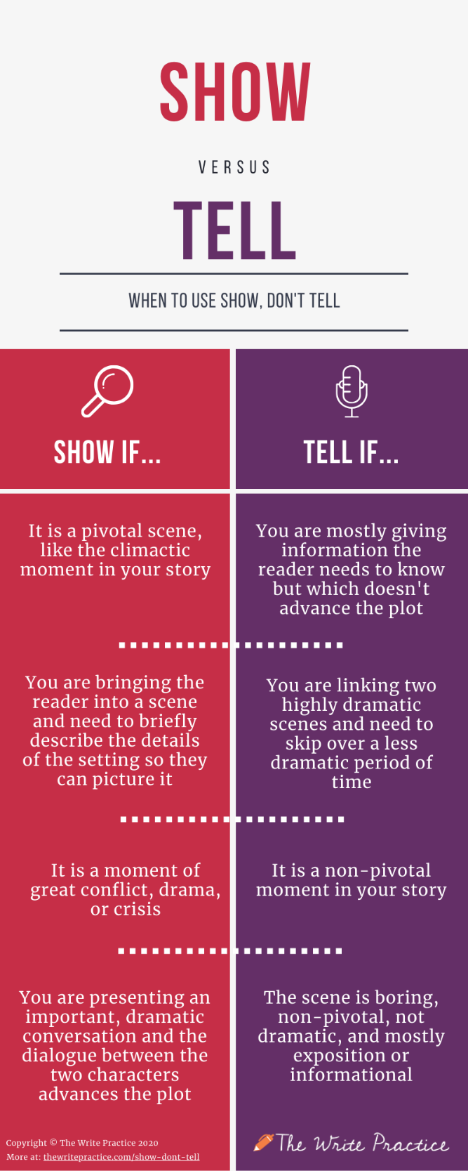
When you tell rather than show, you simply inform your reader of information rather than allowing him to deduce anything.
You’re supplying information by simply stating it. You might report that a character is “tall,” or “angry,” or “cold,” or “tired.”
That’s telling.
Showing would paint a picture the reader could see in her mind’s eye.
If your character is tall, your reader can deduce that because you mention others looking up when they talk with him. Or he has to duck to get through a door. Or when posing for a photo, he has to bend his knees to keep his head in proximity of others.
Rather than telling that your character is angry, show it by describing his face flushing, his throat tightening, his voice rising, his slamming a fist on the table. When you show, you don’t have to tell.
Cold? Don’t tell me; show me. Your character pulls her collar up, tightens her scarf, shoves her hands deep into her pockets, turns her face away from the biting wind.
Tired? He can yawn, groan, stretch. His eyes can look puffy. His shoulders could slump. Another character might say, “Didn’t you sleep last night? You look shot.”
When you show rather than tell, you make the reader part of the experience. Rather than having everything simply imparted to him, he sees it in his mind and comes to the conclusions you want.
What could be better than engaging your reader—giving him an active role in the storytelling—or should I say the story-showing?
Now you try it. Fill in the following information:

The first thing I saw when I woke up __
I heard _
I felt _
I ate for breakfast _
I smelled __
How did you get to school? __

The one below is an example of mine using the info from above.
Theme: Getting up in the morning is hard, but if one loves their job, it is tolerable.
The fluorescent light on the clock face hurt my eyes as I rolled over to shut off the alarm. The number ‘5’ hurt (new word since don’t want to repeat) my brain; why did I agree to teach X-block? Permanently changing the 6:15am to 5:30 was torture. At least it was starting to get light at this time and the birds were singing. I unpeeled the thick blanket off and rolled to the side of the bed. Ugh. It is only Wednesday.
After the usual routine of brushing teeth, showering and dressing, I padded down the stairs to make breakfast; nothing fancy today, just scrambled eggs on toast with a little “I put that s*%t on everything” to spice it up. Thankfully, I had made the lunch kits the night before because I wanted to get out the door to avoid unnecessary traffic today. I had way too much organizing to do; therefore, I had to get an early start to the day so I wasn’t scatterbrained and useless for the next six hours. (deadwood- does not advance the plot or build on my theme so take it out)
Knocking on my son’s bedroom door, I whispered, “Are you up, honey?” “Yah” was muffled by blankets and dreams. Opening the door, my nose twitched. Charlie obviously hadn’t showered after hockey last night.
I whine, but I love my job, and the early morning is nothing compared to working in a 9-5 office with jaded adults who count their days until retirement. Maybe the birds were right; I did have something to celebrate in the morning.

- Now, write a very short narrative story about your morning in which you SHOW your morning, not TELL. You don’t need to have much of a theme- just practice SHOWING. Share it with the people in your Iit group on TEAMS when I say to.

