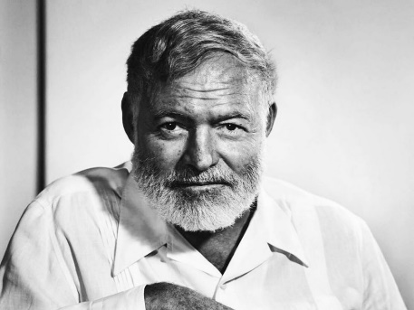
“Up in Michigan”
By Earnest Hemingway
Heminway's Biography- Nobel Prize
Midnight in Paris- video clip of Ernest Hemingway
Realism: “Realism is a movement in art and literature that began in the 19th century as a shift against the exotic and poetic conventions of Romanticism. Literary realism allowed for a new form of writing in which authors represented reality by portraying everyday experiences of relatable and complex characters, as they are in real life Literary realism depicts works with relatable and familiar characters, settings, and plots centered around society’s middle and lower classes. As a result, the intent of realism developed as a means to tell a story as truthfully and realistically as possible instead of dramatizing or romanticizing it. This movement has greatly impacted how authors write and what readers expect from literature.” https://literarydevices.net/realism/

For this story, we will concentrate on the writing style and how it reflects the theme. First, the reader has to analyze for ALL the elements of a short story.

- The best answer for the type of conflict in this story is:
  - Character vs character
  - Character vs self
  - Character vs society
  - Character vs fate
  - Character vs supernatural or machine
  - Character vs nature

- The story is told in
  - Limited omniscient
  - Omniscient
  - First person
  - Objective

- Why is this point of view effective for this story? (2 marks)

- Writing Style- do you read any common writing devices such as parallelism, rule of 3’s, rhetorical questions, repetition, sentence fluency? Mark them on your story.

- Poetic Devices- do you read any devices such as simile, metaphor, allusion, alliteration, onomatopoeia, personification, hyperbole? Label them clearly in the story.

- Symbolism- is there symbolism? If so, what is it and what does it symbolize?

- Irony- is there irony? Do you know if it is verbal, situational or dramatic? Explain

- Literary lens: choose a lens in which to examine this story (psychological lens, feminist lens, Marxist lens). Remember that the lens can be cast on the plot, characters, author and/or reader. Answer ONE of the questions offered. Answer with detail and insight.

- The theme statement is ________ (remember to list the topics first then put it into a universal message that you think the author was trying to say- no clichés and not specific to the characters or plot in the story)

- How is the theme reflected in Hemingway’s writing style?

