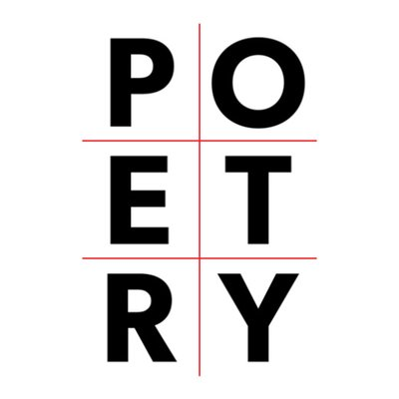
Poetry Analysis and Inquiry
Steps to analyzing poetry
- Read for feeling (read aloud)
- Reread and mark any questions you have with a “?”
  - Vocabulary?
  - Meaning?
- Read for meaning (do the following in any order)
  - Look for figurative devices and record on poem (I have listed the devices under the poem. Can you find them?)
  - Look for connotation- important in understanding poetry
  - Look for imagery (senses)
  - “translate” into your own words at the natural breaks
- Note title- how does it help with meaning or tone?
- What is the structure of the poem? Is it relevant to the meaning?
- Research the author’s biography
- Research the era in which it was written. Historical context is relevant to all writing. (I did some for you already)
Assignment:
- Read and analyze the poem (steps 1-4) with your group. Write all over the poem but leave room on the perimeter of the paper for more writing.
- Write a short biography of the author in a corner. Decide the relevant details. (If I have not done it for you)
- Under the poem, summarize the poem’s
  - Meaning. Use full sentences.
  - tone
- Add images that illustrate the meaning. A talent in art is not necessary but showing meaning through colour and symbolism or metaphor is.
- Connect this poem to the world (Text-World). Explain the bigger picture of this poem. What current events does it address?
- This poem is a source for the questions below. On the poem document, answer ONE of the following questions in point form or prose:
  - How are social norms and attitudes about woman reflected in the literature?
  - How does the text reflect the experiences, the beliefs, and the intentions of the writer?

The Sick Rose
BY WILLIAM BLAKE (1794)
O Rose thou art sick.
The invisible worm,
That flies in the night
In the howling storm:

Has found out thy bed
Of crimson joy:
And his dark secret love
Does thy life destroy.

This poem has the following devices: extended metaphor, apostrophe, assonance, alliteration, allusion, onomatopoeia, symbolism, metaphor, personification, rhyme scheme, cacophony, euphony (within one alliteration)

