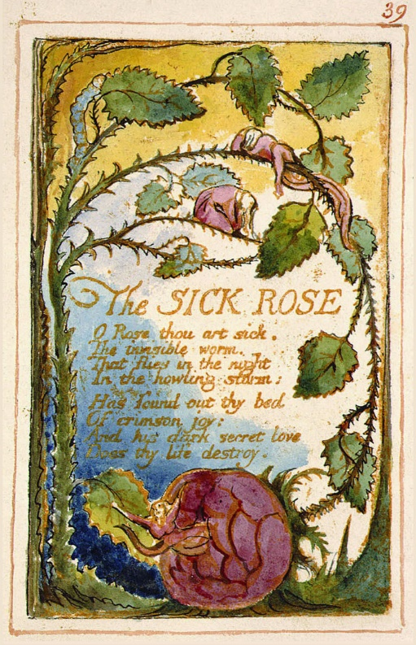
The Sick Rose

(1794)
BY WILLIAM BLAKE
O Rose thou art sick.
The invisible worm,
That flies in the night
In the howling storm:

Has found out thy bed
Of crimson joy:
And his dark secret love
Does thy life destroy.

William Blake
“Poet, painter, engraver, and visionary William Blake worked to bring about a change both in the social order and in the minds of men. Though in his lifetime his work was largely neglected or dismissed, he is now considered one of the leading lights of English poetry, and his work has only grown in popularity.” Poetry Foundation
“Blake was a nonconformist who associated with some of the leading radical thinkers of his day… In defiance of 18th century neoclassical conventions, he privileged imagination over reason in the creation of both his poetry and his images” https://poets.org/poet/william-blake
“Blake loved the world of the spirit and abominated institutionalized religion, especially when it was allied with government” https://www.britannica.com/
Background to the poem:
- Taken from his book called Songs of Innocence (1789) and Songs of Experience (1794) which are books of poetry with his illustrations (see above). Innocence represents the “unfallen world” whereas “Experience” represents original sin, political and social corruption, fear and a loss of childhood vitality.

