Homework: Due Monday
Write or create a poem that reflects on the mood, tone, or theme of ONE of the sources OR a SYNTHESIS of the sources we have read so far. Eg. “Yellow Wallpaper”, “Up in Michigan”, “The Sick Rose”. (Keep it classy and thought provoking, not trashy)
Your poem can be in any structure such as lyric, narrative, free verse or other genres such as Found/BlackOut poetry (using one of the pages from the story) or concrete (see below).
Your poem must have a minimum of three poetic devices UNLESS you are doing a Found or Concrete poem. If so, concentrate on structure as well as word choice.
It is due on Monday on TEAMS. If it is hand drawn, then a photo of the poem can be used.
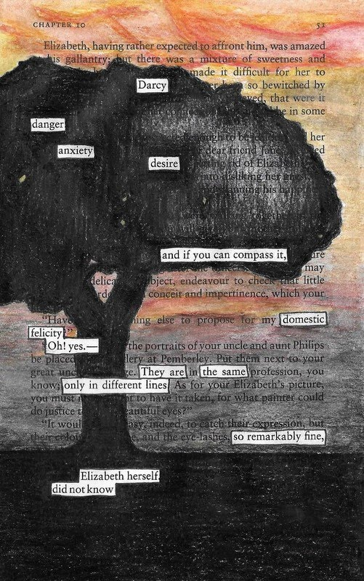
Figure 1: Found/BlackOut Poem for Pride and Prejudice. Poem created by Rachel Flemmer
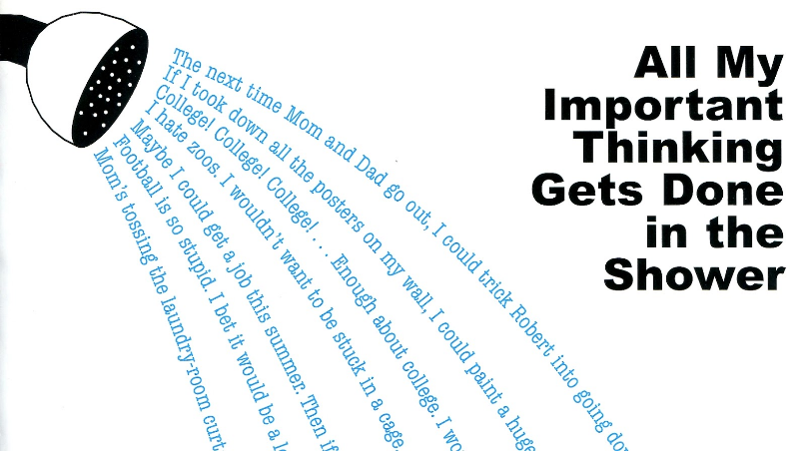
Figure 2: Concrete Poem: This one is done by John Grandits from his book “Blue Lipstick”

