Creative Writing 12

Welcome to Creative Writing 12!
I am excited to get to you know and read what you have to say! This is the first time I have taught this course so it will be an exploration together. As in any creative process, I will be adapting, revising and modifying as we go along. Be flexible and vocal; don’t be afraid to give suggestions in a respectful way.
We will be exploring what it means to be a creative thinker, not just a creative writer. We will learn how to articulate our thinking and our creative process through reflections and discussions.
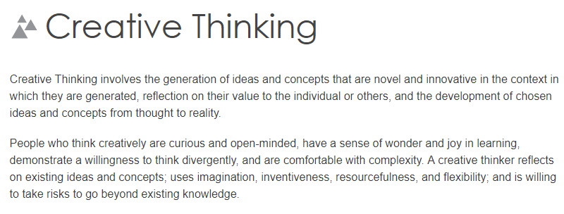
Creative Thinking Competency

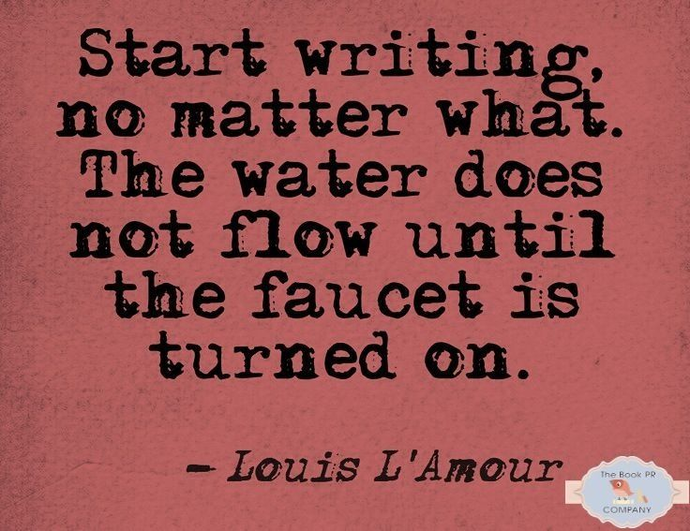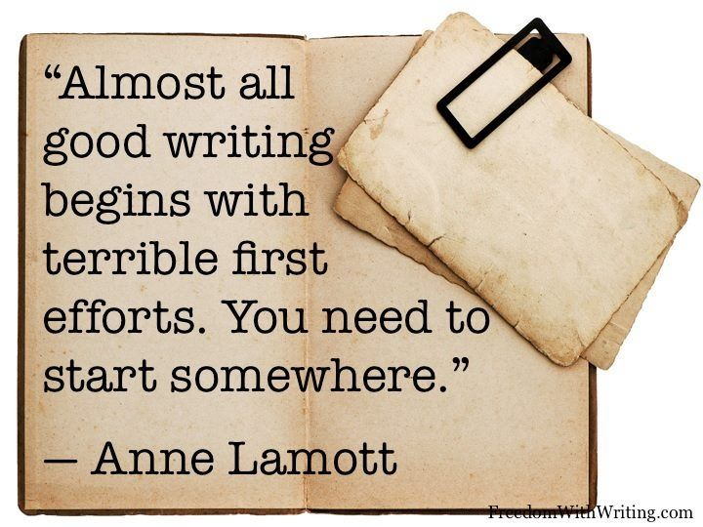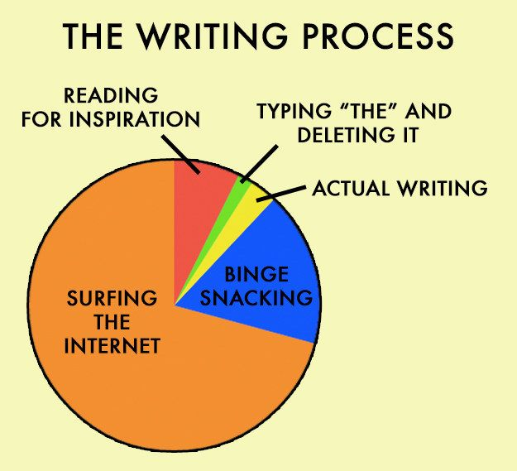

We will be following the Creative Writing Curriculum:
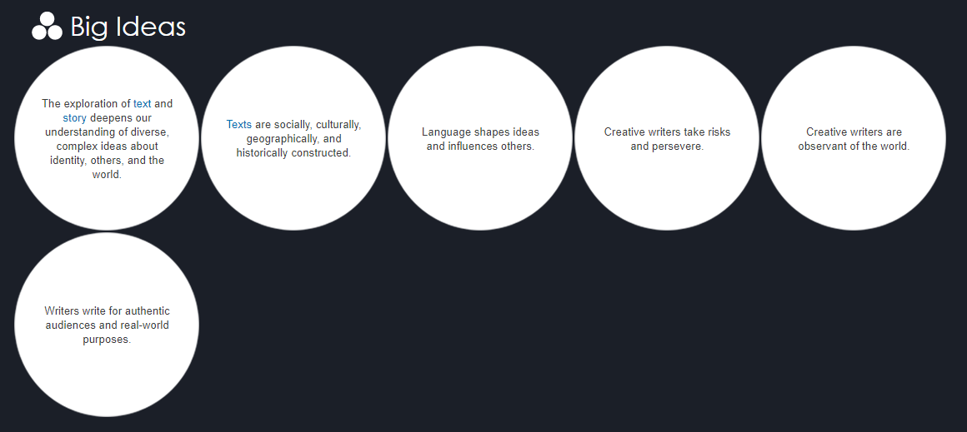
Creative Writing BC Curriculum
We will:
- Deconstruct narratives and poetry to understand devices, identity, and style. I call this “read like a writer”.
- Explore the style of famous authors
- Explore your own writing style
- Explore your identity and how it influences your writing and your perception of other writing
- Write a variety of genres which may or may not include narrative non-fiction, poetry, short story, online games, blog posts, social media posts, and marketing
- Write for publication
- Learn to give constructive, positive feedback when editing
Organization:
- We will use OneNote for your journaling (you are welcome to use your own platform such as Word or a journal but know you will have to copy it to OneNote so I can see your progress and completion)
- We will use TEAMS for virtual meetings and to ‘hand in’ final assignments
- I use my Edublog for “Today’s Classes”. This is where I post instructions for the day and the PowerPoints and documents.

Assessment:
- Portfolio based (5 poems in a variety of forms, one short story, one narrative essay, blog posts, reflections) [note: due to the structure of the quarter semesters, this may change. It is not my intent to overwhelm you with work so let’s see how this “semester” goes]
- Emphasis on completion and growth more than creative ability to write
- More formative assessment than summative. I will be holding conferences as much as possible. You will be learning how to edit and give constructive feedback as well.
- Those that engage in dialogue and participate in activities with an open mind, will ultimately learn more; therefore, to encourage participation, there will be a self-assessed mark that will count for 10% of your total grade.
- To encourage completion of assignments, 15% of your total grade will be based on completion. For those assignments that are completion based, (reflections, writing analysis, prompts, etc) you will get a mark out of /3.

0 | Incomplete
1 | Mostly complete but late
2 | Mostly complete with some effort and on time
3 | Fully complete with effort and on time

Semester Outline:
- Part A- Creative Process and Thinking
- Part B- Read as a Writer: Poetic Devices, Writing Analysis, and Personal Narratives
- Part C- Creative Writing for Social Media and Digital Platforms
- Part D- Poetry
- Part E- Short Stories

Hybrid Learning
- I will be taking attendance. During hybrid learning, you are expected to be in “class” on your assigned day plus Wednesday. On the days you are not required to be in “class” you will have work to do but it can be done on your time. THERE MAY BE A DAY OR TWO THAT I ASK YOU TO BE THERE FOR BOTH DAYS.
- You are expected to have your camera on at all times and be sitting at a desk or a table NOT lying down on your bed. Let’s pretend you are in the classroom.
- If your camera does not work on your computer, then I would ask you to get it fixed. Please let me know if you do NOT have a camera and we can talk about options.
Looking forward to reading your words

