Literary Lens Assignment #1
Each person in the group will choose ONE of the lens in which to critically examine your novel.
Due Friday, May 15th during class.
Important: on Friday, you will discuss your lens with your group first THEN compile all the responses into a padlet. I will show you how to do this on Friday.
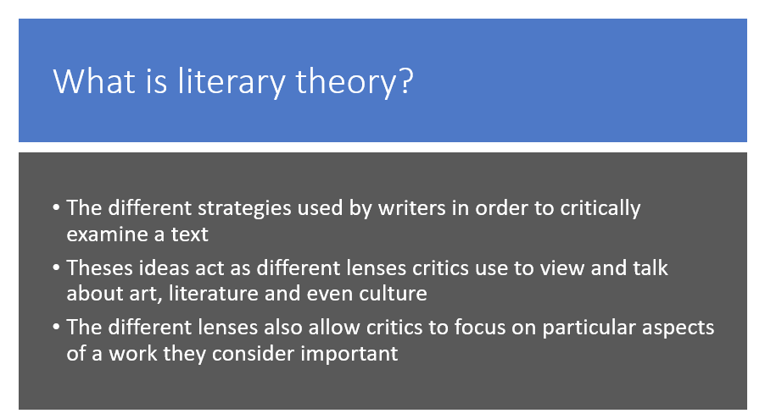
Your assignment:
- Choose ONE lens each
- Answer ONE-TWO of the questions in a paragraph citing ONE to TWO pieces of evidence from the novel. Quotes are encouraged but not mandatory (see below)
