Please post this assignment in TEAMS by Thursday, April 9th
Respond to ONE of the following images in a genre or your choice:
- Lyrical poem (free verse or structured)
- Short, short story (max. 500 words)
- Persuasive paragraph (approx. 250-500 words)
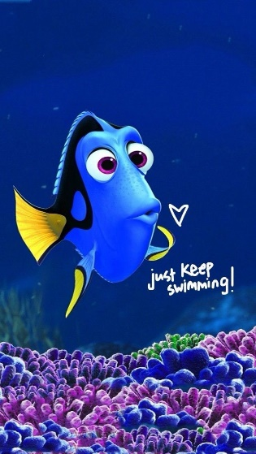
- Personal narrative (250-500 words)
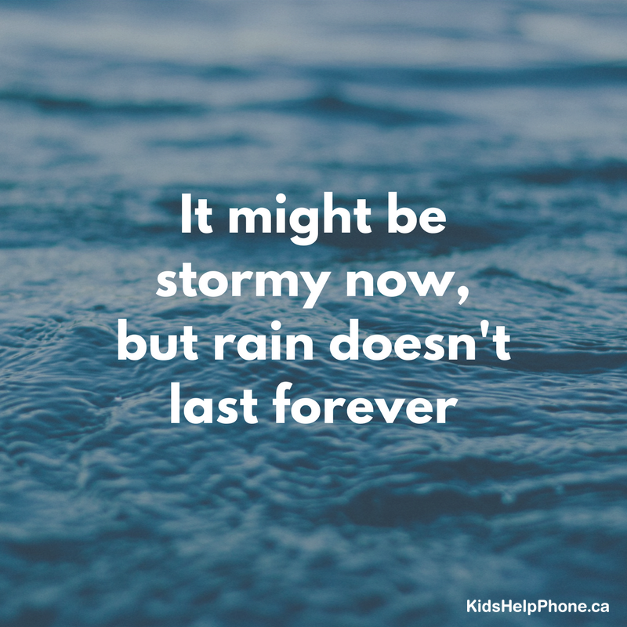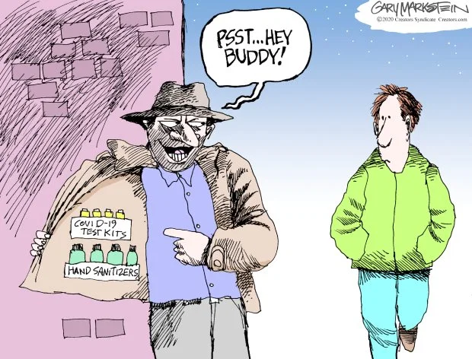
https://www.mercurynews.com/2020/03/11/cartoons-coronavirus-outbreak-classified-as-pandemic/
https://edmontonjournal.com/news/politics/david-staples-alberta-is-canadas-dragon-slayer-when-it-comes-to-preparing-for-covid-19/

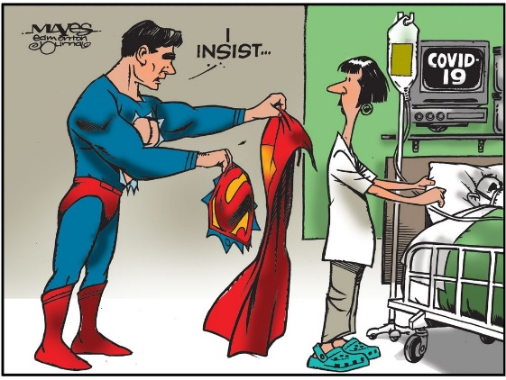
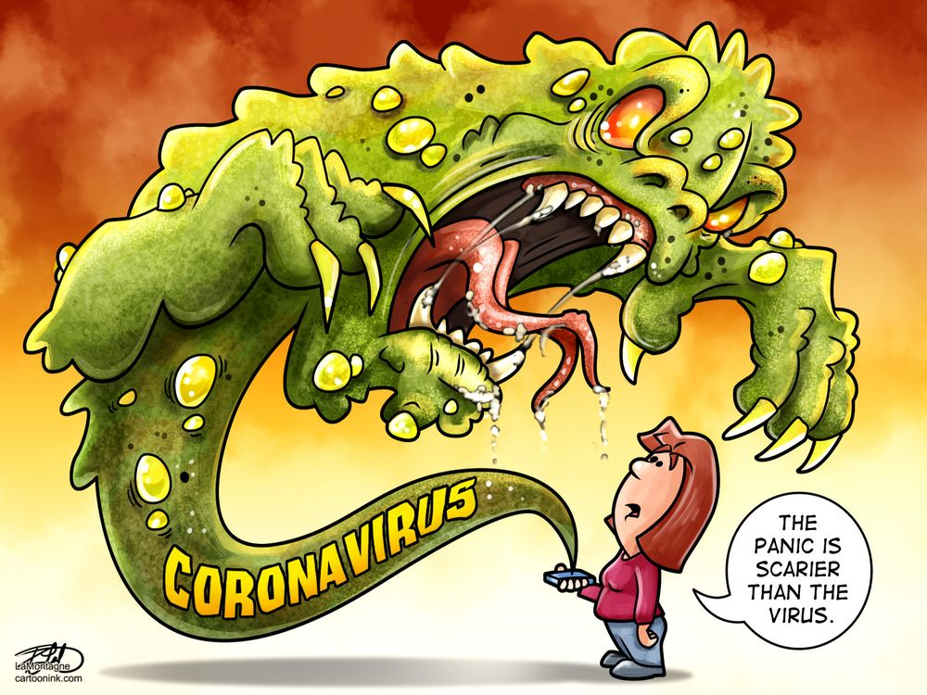
https://calgaryherald.com/gallery/the-heralds-latest-editorial-cartoons/

Poem

When the media portrays you like the virus,
When people threaten you for bringing this illness.
When the world turns its back on your colour,
You’ll know what it’s like to be my brother

If I ever have children,
I’d tell him;
People will tell you that your life is worthless
That your skin colour is a lie and your people are brainless
They’ll tell you to integrate int’ their great society
But accepting everybody except you because you’re Chinese
Accepting nobody in reality when they’re in times of need
And put on a show and say they love everybody equally

If you ever are mugged because of the colour of your skin,
If you ever were treated as if being Chinese is a deadly sin
If you been slanged at and told to keep the struggle within
You can tell me you know what it’s like to be Asian

“Not to be racist” but it’s the Chinese virus
“Screw them chinks straight up” and incite the violence
“2ND case of China Virus” on headlines in The Province
America I’m talking to you; I’m looking for an explanation

I know you want me dead; I can see it in your eyes
I know you want me gone; I feel it when I walk by
Anybody telling me they care for me, sorry that’s just a lie;
that
I don’t believe in anymore, you don’t got the right
To tell me you care for someone who doesn’t got any rights
I blame the left, I blame the system, I blame the far right
I blame anybody and everybody who puts a value on my life
And I blame everybody who acts like there’s no privilege being white

Watching my brothers and sisters get abused is an insult to me
When we got to this country we just wanted to be free
But if I’m being honest with you it feels like quite the contrary
I’m a slave to the people born less Asian than me

This what it feels like to be Asian
We don’t feel accepted,
We don’t… feel accepted…
But everybody else acts like I don’t know what I’m saying
And maybe I don’t anymore that’s exactly why I’m saying
Just leave me the hell alone didn’t think I’d have to say this

You’re killing my people and the world doesn’t even know it…

Hey that was my poem and I don’t wanna come across as rude, so I thought I’d explain some of the words I chose:

- Everything in quotes are things that have been said towards Asians after the virus broke out. These have either been aired on television, spoken by celebrities, or even written in ‘unbiased’ news articles. I did have to censor a word in one of the quotes.
- This poem is about Asian oppression and how nobody recognizes racism against Asians. It’s not, in any form whatsoever, meant to discredit the amounts of suffering other racial and ethnic minorities have suffered at the hands of racists.
- I have made the generalization that racists are predominantly of white skin colour, and I recognize the absolution. There has also been support from people of white skin, but it’s sometimes outweighed by the negatives we hear online.
- My comment about Asian’s being slandered as brainless is directed at individuals who believe that, just because we are traditionally useful of a different governmental system, we have been brainwashed to the core; which is anything but the truth.
- White privilege is something I address in this. I recognize that there is also affirmative action to somewhat balance this. However, I do believe that privilege of skin tone contributes to why Asian voices are heard less in the media.
- I use male pronouns because I am a male, I realize that female Asians have the unfortunate curse of, not only being racially targeted, but also sexually abused. It’s just a topic I don’t feel comfortable touching, as I have no first-hand experience.

