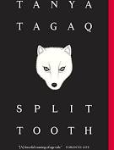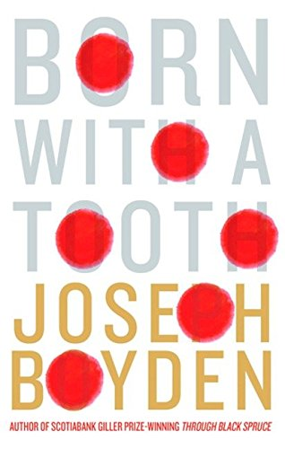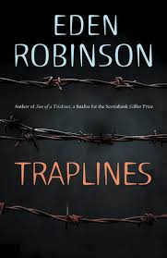

Short Story Circles
You will be split into three groups. You have two days to read and complete the assignments for each section listed below. All assignments are to be on OneNote and organized properly. Each story has its own “page” in the “Indigenous” section.
For EACH story, you are asked to

  - Research a little bit about the authors. What is significant about their lives that may be reflected in their stories? Record some points at the beginning of each assignment.
  - Choose two principles of learning (see below) that are highlighted in the story. In a paragraph, analyze how the story reveals these principles of learning. Use quotes and evidence from the story to support your ideas. You will have a total of 6 paragraphs by the end of the unit.
  - Answer the questions that are assigned to each section.

An arts-based response to ONE story. This can be in the form of a poem, a drawing, a symbolic representation, a famous painting with an explanation of its relevance, a song with the lyrics posted and your connection, a famous (or not) sculpture that reflects the themes; your choice! An accompanying write up would be helpful.

Here are the stories and questions:
  - Inuit: Honouring the Child
    - Split Tooth by Tanya Tagaq- pg. 11-16, 18-21, 36-40
      - Highlight examples of personification (there are many). Why does Tagaq use personification so frequently? What is she usually personifying? How does this writing style reflect her identity and the Inuit view of the world?
      - Connect personally to ONE of the narratives. Write me a short anecdote about this connection. Eg. Did you have any strange rituals as a child?
      - Find one example of humour in the stories. Record the quote and why you thought it was funny.
      - Refer back to the ppt, slide #10 (Influence of the land). How is Tagaq influenced by the land?
      - Optional challenge: Analyze the two poems and summarize the meaning.
  - Allegory in Stories
    - “Legend of the Sugar Girl” by Joseph Boyden
      - What was the effect of the residential schools on the “Sugar Girl”? This can be point form (and there are many effects).
      - What is an allegory? Look up the definition and find other examples of allegories in literature.
      - Is sugar an allegory for colonization? Find evidence to support or refute this claim. You should have 3-5 points.
      - Boyden uses a circular structure in this story. Find it. What other common Indigenous story telling traits are visible in the circular structure? Go back to the ppt to be reminded about the uniqueness of their stories.
      - Optional challenge: How does this story reflect the historical experiences of Indigenous people in Canada?
  - Relationships and Resilience
    - “Traplines” by Eden Robinson
      - Why do you think Will chooses to run away to Vancouver instead of living with the Smythes’s?
      - Robinson uses the imagery of Christmas scenes quite often. What was the purpose of doing this? The correct answer is NOT that the story is set in December.
      - What memories are fond to Will? Refer back to the ppt, slide #10 (Influence of the land). How is Will influenced by the land?
