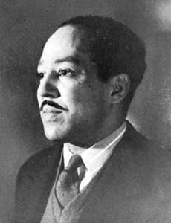
The Negro Speaks of Rivers
By Langston Hughes

I’ve known rivers:
I’ve known rivers ancient as the world and older than the flow of human blood in human veins.

My soul has grown deep like the rivers.

I bathed in the Euphrates when dawns were young.
I built my hut near the Congo and it lulled me to sleep.
I looked upon the Nile and raised the pyramids above it.
I heard the singing of the Mississippi when Abe Lincoln went down to New Orleans, and I’ve seen its muddy bosom turn all golden in the sunset.

I’ve known rivers:
Ancient, dusky rivers.

My soul has grown deep like the rivers.
Langston Hughes, “The Negro Speaks of Rivers” from Collected Poems. Copyright © 1994 by The Estate of Langston Hughes. Reprinted with the permission of Harold Ober Associates Incorporated.

- Read this poem several times: the first for feeling and the second for meaning
- Question as you read! OR define what you already know. Record these questions or comments on the sheet.
- Answer the researchable questions (eg. Vocab, author)
- Read for a third time, looking for a deeper understanding by summarizing in your own words line by line or stanza by stanza
- Read for sound- how does this poem “sound” to you?
- Read for poetic devices. Look for allusions, similes, personification, extended metaphor, symbolism

Structure (how does the structure reflect identity??)

Mood:
Tone:
Summary and purpose:

