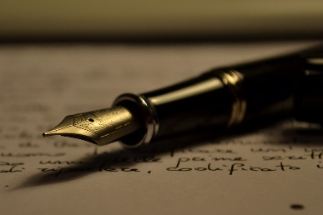
Compare and Contrast Essay- Assignment
In English writing and analysis, compare and contrast involves taking two pieces of media and finding similarities and differences between them. Usually, the comparasion surrounds a theme (for example, culture, loss, genocide, revenge, identity, etc.) By putting the two pieces together and looking for similarities and differences, we whould be able to get new insights.
Criteria:
- 4-5 paragraphs (max 3 pages)
- double spaced, 12 font, times new roman
- Formal essay (no “I” “you” or contractions)
- Present tense when analyzing literature
Due on Thursday, February 27th at the beginning of class: printed.
Here are the steps to creating your own compare and contrast essay:
- Start with the question and two sources.

How does an author express their identity through poetry?
Sources:
- Juicy
- Yet Do I Marvel
- The Negro Speaks of Rivers
- Another Harlem Renaissance poem

- Brainstorm: Create a mind map of all the ways the poems used poetic terms and devies to reflect their identity.

- Brainstorm: Use a Venn Diagram OR a Chart to find the similarities and differences of TWO sources only based on the criteria above.

- Thesis: Answer the question with your pieces of literature. The answer to your quesition is your argument and will be the anchor of your paper.

- Collect evidence from the text that support your argument and use quotes. Use the graphic organizer given to you.

- Check the rubric. Are you aware of the criteria? The expectations?

- Write the essay:
- MLA formatting
- 4-5 pages (trim the “deadwood” if too much)
- No “you” or “I”
- Present tense
- I will be looking at your use of all grammar we have learned in class (comma splices, active vs passive writing, commas)
- You will have one-two days to fill in an outline. The outline can be done for homework as well as in-class.
- You must have your outline checked before you can begin your essay.
- We will spend three days in class writing. IT IS NOT TO BE TAKEN HOME. It is an “in-class essay”

- Revise for mechanics and grammar. Highlight the thesis and transition words

