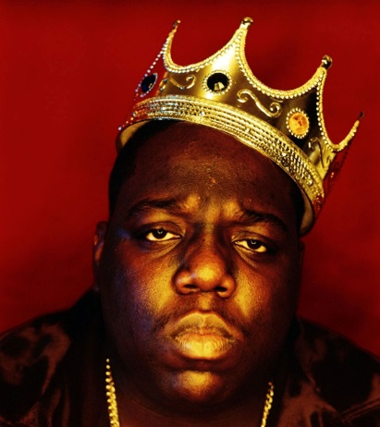
“Juicy” by Notorious BIG

It was all a dream
I used to read Word Up magazine
Salt’n’Pepa and Heavy D up in the limousine
Hangin’ pictures on my wall
Every Saturday Rap Attack, Mr. Magic, Marley Marl
Now honies play me close like butter played toast
From the Mississippi down to the east coast
Condos in Queens, indo for weeks
Sold out seats to hear Biggie Smalls speak
Livin’ life without fear
Puttin’ 5 karats in my baby girl’s ears
Lunches, brunches, interviews by the pool
Considered a fool ’cause I dropped out of high school
Stereotypes of a black male misunderstood
And it’s still all good
We used to fuss when the landlord dissed us
No heat, wonder why Christmas missed us
Birthdays was the worst days
Now we sip champagne when we thirst-ay
Uh, damn right I like the life I live
‘Cause I went from negative to positive
And it’s all good.

Poetic Devices: allusion, assonance, consonance, simile, oxymoron, alliteration, symbolism, internal rhyme,
Tone:
Mood:
Topic:
Structure/Type:
Summary:

How do the devices enhance meaning and reflect his identity?

