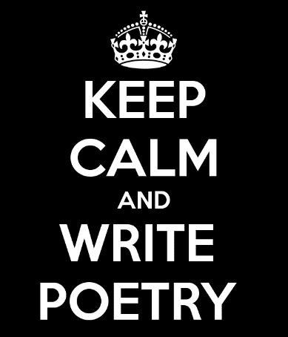
Poetry Assignments
- Concept Map Assignment –February 20th, 2020
Create a concept map from the definitions in the Poetry Terminology booklet.
Create a coloured visual map that shows the relationships between the words. It can on a piece of paper OR an app of your choice. Try https://bubbl.us/ or https://www.canva.com/
- Write the word
- Write the definition
- Give an example of this concept for the words that are in the Word Play, Sound Devices, Comparison categories.
  - Eg. Simile- comparing two things using “like” or “as”. Playful as a puppy.
  - The examples may come from the internet- may I suggest www.literarydevices.net
  - For Types of Poems, Verse Forms and Rhythm and Rhyme, you only need the word and definition (not enough room to write out examples)
- To get full marks, use your own examples- not the ones in the reference booklet!!!
Be sure to show the relationships between the concepts by linking them to their “parent”. See examples on my board or online.
Marks are based on:
- Presentable and easy to read
- Unique examples of the device NOT from the booklet
- Correct terms
- Colour to show relationships
- Images to represent your thinking
Mark is out of /10
- You will NOT get marks for fine lining so don’t waste your time But it does have to be readable.

