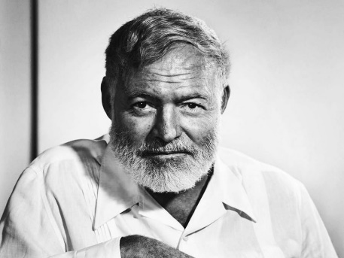
“Up in Michigan”
By Earnest Hemingway
Heminway's Biography- Nobel Prize

- The best answer for the type of conflict in this story is:
  - Character vs character
  - Character vs self
  - Character vs society
  - Character vs fate
  - Character vs supernatural or machine
  - Character vs nature

- The story is told in
  - Limited omniscient
  - Omniscient
  - First person
  - Objective

- Why is this point of view effective for this story? (2 marks)

- Writing Style- do you read any common writing devices such as parallelism, rule of 3’s, rhetorical questions, repetition, sentence fluency? Mark them on your story. (depends)

- Poetic Devices- do you read any devices such as simile, metaphor, allusion, alliteration, onomatopoeia, personification, hyperbole? Label them clearly in the story. (depends)

- Symbolism- is there symbolism? If so, what is it and what does it symbolize? (1 mark)

- Irony- is there irony? Do you know if it is verbal, situational or dramatic? Explain (2 marks)

- Literary lens: choose a lens in which to examine this story (psychological lens, feminist lens, Marxist lens). Remember that the lens can be cast on the plot, characters, author and/or reader. Answer ONE of the questions offered. Answer with detail and insight. (3 marks)

- The theme statement is (2 marks) (remember to list the topics first then put it into a universal message that you think the author was trying to say- no clichés and not specific to the characters or plot in the story)

