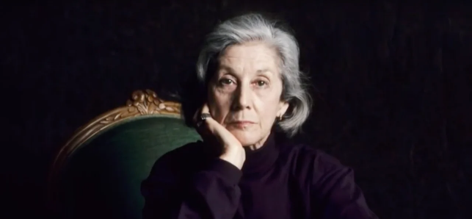
“The Ultimate Safari”
by Nadine Gordimer
Background: Nadine Gordiner was born in South Africa in 1923. She is a white South African whose denuciations of apartheid caused some of her works to be banned by the white minority government in her homeland. https://www.nobelprize.org/prizes/literature/1991/gordimer/facts/

- The best answer for the type of conflict in this story is:
  - Character vs character
  - Character vs self
  - Character vs society
  - Character vs fate
  - Character vs supernatural or machine
  - Character vs nature

- The story is told in
  - Limited omniscient
  - Omniscient
  - First person
  - Objective

- Why is this point of view effective for this story? (2 marks) __________________________________________________________________________________________________________________________________________________________________________________________________________________________________________
- Writing Style- do you read any common writing devices such as parallelism, rule of 3’s, rhetorical questions, repetition, sentence fluency? Mark them on your story. (depends)

- Poetic Devices- do you read any devices such as simile, metaphor, allusion, alliteration, onomatopoeia, personification, hyperbole? Label them clearly in the story. (depends)

- Symbolism- is there symbolism? If so, what is it and what does it symbolize? (1 mark) ____________________________________________________________________________________________________________________________________________________________

- Irony- is there irony? Do you know if it is verbal, situational or dramatic? Explain (2 marks) __________________________________________________________________________________________________________________________________________________________________________________________________________________________________________

- Literary lens: choose a lens in which to examine this story (psychological lens, feminist lens, Marxist lens). Remember that the lens can be cast on the plot, characters, author and/or reader. Answer ONE of the questions offered. Answer with detail and insight. (3 marks) ________________________________________________________________________________________________________________________________________________________________________________________________________________________________________________________________________________________________________________________________________________________________________________________________________________________________________________________________________________________________________________________________________________________________________________________________________________________________________________
- The theme statement is (2 marks) (remember to list the topics first then put it into a universal message that you think the author was trying to say- no clichés and not specific to the characters or plot in the story) __________________________________________________________________________________________________________________________________________________________________________________________________________________________________________

