The Human Condition- Expository Paragraph
Write an expository paragraph about a source that explores the human condition.
Criteria:
- A song, poem, video, book or movie.
- It must answer ONE of the inquiry questions posted on the board.
  - Begin with the question as your title
  - Introductory sentence should have the title and the author/director
  - In an expostiry paragraph, summarize the plot.
  - Somewhere in the paragraph, describe how this source shows us the human condition. Use italics to be clear.
  - The conclusion should be the message, the theme of this piece and how it relates to the human condition. Be sure to bold it.
  - Add an image of your source at the bottom.
- Print and give to me for assessment. Due _________. (see rubric below)

After it is marked:
- Post your paragraph on your blog with an image of the source
- TAG: HumanconditionB (your block)
- Present your source to the people in your group. Explain why you chose this source and explain the significance to humanity.

Concept/ criteria | Not meeting expectations  (0-5) | Partially meets expectations  (5.5- 7) | Meets expectations  (7.3-8.5) | Exceeds expectations  (8.6-10)
Clarity of writing and style | no sense of organization; Unclear, or unedited; language is perhaps inappropriate; writing errors distracting | Some clarity issues or disorganization of key points; perhaps an overly casual writing style; some mechanical errors that distract the reader  Summary does not relate to the conclusion | Post is well developed; clear progression of ideas; thoughts are given in a cohesive manner; minor mechanical issues  Summary relates to the conclusion | -Ideas organized around a central concise point/discussion;  -organization of ideas propels reader/post on; thoughtfully composed  Summary strongly relates to the conclusion
Critical thinking (connections to the Inquiry questions) | Provides inaccurate or unoriginal information;  repeats or regurgitates information at a surface/ knowledge level | Identifies the central problem/idea/connection, but does not analyze or synthesize or answer the question well.  Too simple in analysis | Could be slightly more insightful and detailed  Answers the question but could go beyond immediate analysis | Thoroughly synthesizes the central problem/idea/  connections with other relevant information;  -Insightful and detailed  -Goes beyond the obvious answer
Use of enhancements/ the visual - media | Message in the media chosen is not apparent  No image |  | Image of the source is present and the appropriate size and quality
Organized | No organization- too many missing criteria | Something is missing: Introduction, author and title formatted properly, analysis, conclusion | Introduction, author and title formatted properly, analysis, and bolded conclusion are all present

Short summary or explanation of the video: note that the summary is connected to the question.
- Introduce the source and be sure to format title properly. Add the author/director too.

How does one find beauty in life despite hardship?
In the “Humans” video, directed by Yana Arthus Bertrand, Francine Cristophe recounts the story of her experience as a young girl in a Nazi concentration camp. Her mother had saved a small piece of chocolate for when Francine may be overwhelmed or especially sad due to the suffering. When a fellow inmate went into labour, Francine gave her the coveted chocolate in order to give her a small piece of luxury or maybe a reminder of their old life outside the camp. Francine knew that the new mother would need it more than herself. Many decades later, the baby of that woman (now an adult) recognized Francine and gave her chocolate in return. Humans can be cruel and barbaric; we need to find joy and beauty, no matter how small, to survive the darkness. This video shows that in times of extreme hardship, sometimes the smallest gesture of selflessness can give someone hope and happiness.
Theme statement in BOLD
Add a comment about how this source shows the human condition

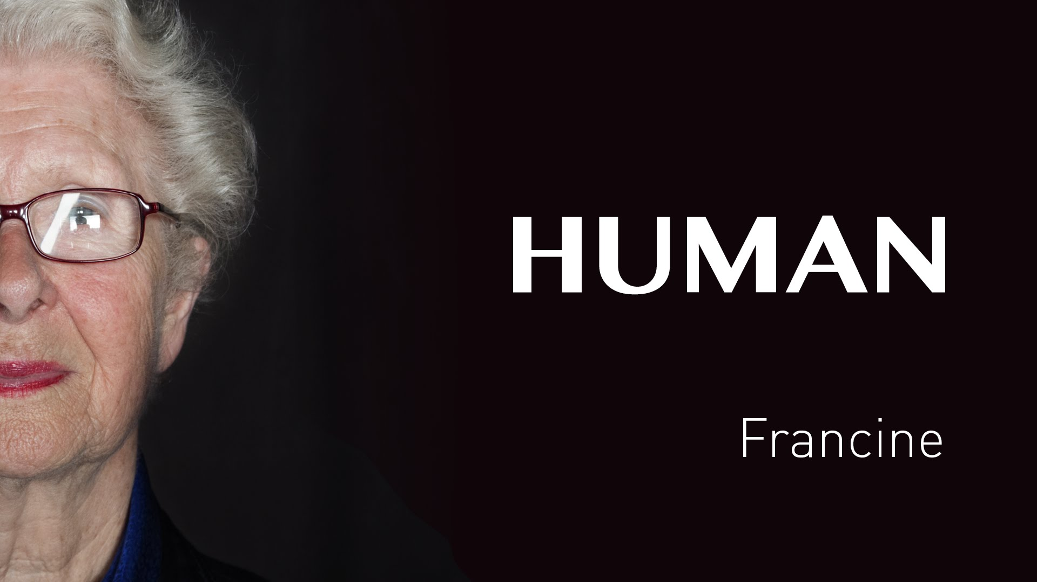

How does one survive war and conflict?
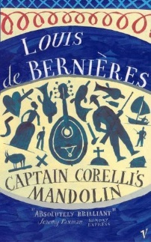
The novel Captain Corelli’s Mandolin by Louis de Bernières takes place in Greece during World War II. The protagonist is an Italian soldier who is billeting at a local home where the beautiful Pelagia and her father reside. Despite their misgivings, the two Greeks cannot help but learn to like the engaging and charismatic Captain of the Italian forces. In time, Pelagia and Corelli fall in love despite the chaos and brutality surrounding their existence. The secondary characters find love in other ways: one soldier loves his pet mouse, Pelagia’s ex-husband loves his politics, the doctor loves his daughter and the big burly Carlo loves Corelli. Humans have a great capacity to give and receive love. This novel shows that love comes in many forms and motivates us to survive the hardship to protect that love.

