Literary Studies and Composition 10- Honours
The aim of Literary Studies and Composition 10 is to provide students with opportunities for personal and intellectual growth through speaking, listening, inquiry, reading, viewing, writing, and representing to make meaning of the world and to prepare them to participate effectively in all aspects of society.
The goals of Literary Studies and Composition 10 is to:
- comprehend and respond to oral and written language critically, creatively and articulately.
- communicate ideas, information, and feelings critically, creatively and articulately using various media
- think critically and creatively; reflect on and articulate thinking and learning to be engaged and educated citizens
- question and explore the human condition through inquiry of a variety of texts and genres
- develop a continuously increasing understanding of self and others
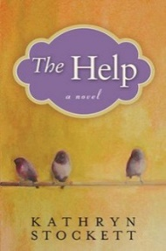

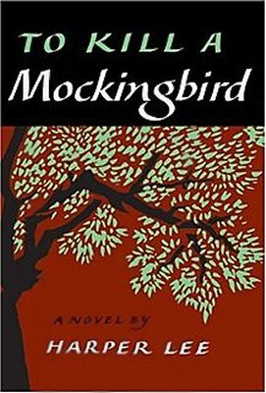
Content
Prose: Short Stories, Novels, Of Mice and Men (maybe)
Poetry: Traditional, Contemporary, Spoken Word
Drama: Othello or Much Ado About Nothing (Speed version)
Writing: Personal Reflections; Descriptive, Narrative, and Synthesis essays; Slam Poem
Inquiry: Exploring the human condition through literature and other sources
Grammar and Vocabulary: The mechanics of good writing and building sophisticated vocabulary on NoRedInk
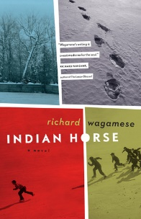
Assessment
Assessment will be both Formative (homework checks, informal feedback, suggestions, and conferences, to help you learn) and Summative (to demonstrate what you have learned such as tests, projects, essays). Assessment will be based on skills, comprehension, creativity and participation.
Essays/projects/tests/assignments are worth 90% of the final mark.
Blog postings, reflections and essay corrections are worth 5% of your mark
NoRedInk grammar quizzes are worth 5% of your mark

Materials
Must have access to your edublog
Must bring everyday:
- Writing utensil
- Electronic device with a charger with the following files:
- English texts/books you have been assigned

