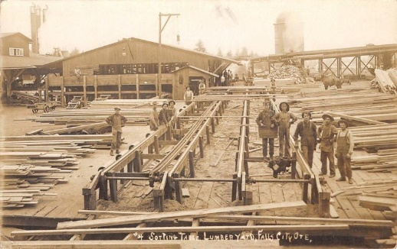
“The Last of Her Sons”
By Alden Nowlan
Background: “Nowlan grew up in rural poverty. His mother, Grace Reese, was 15 when he was born, his father, Freeman Nowlan, a manual laborer. Along with his younger sister Harriet, he was largely raised by his paternal grandmother. Nowlan was forced to leave school at age 10. At 14, he worked in a local sawmill, and by 16 he was walking or hitchhiking 30km to the county library where he began to pursue his lifelong passion for learning and reading. For most of his career, Nowlan supported his writing as a nightshift journalist and editor at newspapers in Nova Scotia and New Brunswick. For Nowlan, poetry was “all about people, and to hell with literature.” https://www.thecanadianencyclopedia.ca/en/article/alden-nowlan

- How would you describe the main characters? Use sophisticated adjectives. Find an example of direct characterization and indirect characterization for evidence.

 | Judd | Ethel | Skipper
Adjective
Evidence: Direct characterization (use quotes or paraphrase)

Adjective
Evidence: Indirect characterization

- What is Ethel Syverson’ main motivation in this short story? What did she want for Skipper?

- What are the early signs that Skipper was shaping his own identity?

- What can we infer about Ethel’s behavior at the end of the story? What did she realize?

- What is the story saying about the formation of one’s identity?

- Reread Alan Nowlan’s biography above. How does this story reflect his own identity?

- Do you think a writer can detach from their identity and write completely independent of their own experiences?

- Read this story from a psychological lens and analyze each character
Character | Id | Ego | SuperEgo
Skipper

Judd

Ethel Syverson

- How does looking at this story through the psychological lens increase our understanding of one’s identity?

