Quotation Review
https://owl.english.purdue.edu/owl/resource/747/02/
When citing your reference quotes for one source (in this case, Lord of the Flies), use the MLA (Modern Language Association) method. This means:
- Follow the rules for punctuation as I have taught you
- Within the brackets, state the author’s name and the page number. Eg. …Piggy” (Golding 13).
- You only have to do this once- the rest of the time, you just have to input the page number.
Eg…. Ralph” (15).
When quoting multiple speakers in less than four lines, put the quote in double quotation marks then single.
Eg. “’The rules, you are breaking the rules,’ said Ralph. ‘Who cares,’ said Jack” (Golding 44).
If you are quoting more than four lines, use block quotations that are indented and no quotation marks. Always begin with a colon and cite the page number at the end.
Eg. Piggy was the first to recognize the need for order and structure:
‘We got to find the others. We got to do something.’
Ralph said nothing. Here was a coral island. Protected from the sun, ignoring Piggy's ill-omened talk, he dreamed pleasantly.
Piggy insisted.
‘How many of us are there?’
Ralph came forward and stood by Piggy.
‘I don't know’ (Golding, 25).

When citing your reference quotes from a website:
- Be sure to have a correctly formatted bibliography at the end of your essay. See end of the article for the correct formatting. Use “Easy Bib” or “Citation Machine” for formatting.
- Within your essay, you can include the name of the article in the lead up to the quote OR you can put the website name within brackets
  - Eg. According to Amanda Leigh Mascerelli, the teenage brain acts on “an endless parade of choices” (Societyforscience.org)
  - OR Golding understands that the teenage brain “is locked in a tug-o-war between logic and reward” (Mascerelli).
Correct the following sentences using the correct commas or quotations:
- When Jack was speaking without the conch Ralph said “the rules! You’re breaking the rules”!
- An example from this book is when Jacks says “i’m not going to play any longer. Not with you” (140)
- … so you shut up.” (pg 39) Jack is showing us he does not care about those rules.

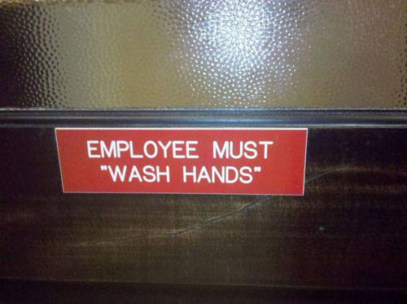
Join sentence pairs using, a subordinate conjunction and a comma.
1. Many people believe in UFO’s. Few have ever seen one.
___________________________________________________
2. Do I have to wear glasses? Can I just squint and hope for the best?
___________________________________________________
3. The storm is coming. We should be safe on the island with Ralph.
___________________________________________________
4. The team’s record improved. The coach still needs to be fired.
__________________________________________________
Introductory Commas- insert where necessary.
- Yes I am sure she did do her homework.
- Seriously Mrs. Thomasen I hate this grammar stuff.
- Although learning about commas is boring I know that I need to be able to write well to communicate.
- Before coming to the party the girls had to do their hair.
- Until I knew how to insert commas in the right place my writing was mediocre.
The Comma in a Series- insert where necessary
- You will be required to read short stories plays poems and essays in English.
- I did not know where you were how you were or when you would return.
- We stumbled into the hall bumped into the chair turned on the light and laughed in relief.
- For lunch we served soup tomato juice ham and cheese sandwiches.

The Comma used to set off expressions, which interrupt the sentence.
- My teacher the best in the world loved to read stories to us.
- The band Pink Floyd popular in the 70s just released another album despite their age.
- Tim Horton the restaurant guru used to be a hockey player in the NHL.
- Love and kisses are the spice if not the sugar of life.

