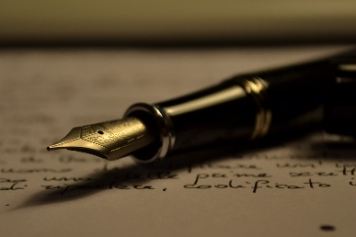
Compare and Contrast Essay- Assignment
In English writing and analysis, compare and contrast involves taking two pieces of media and finding similarities and differences between them. Usually, the comparasion surrounds a theme (for example, culture, loss, genocide, revenge, hatred, etc.) By putting the two pieces together and looking for similarities and differences, we whould be able to get new insights.
Criteria:
- 1000-1500 (4-5 paragraphs)
- 1.5 spacing, 12 font, Times New Roman
- Formal essay (no “I” “you” or contractions)
- Present tense when anayzing literature
Due on Friday, November 22nd at the end of the block
Here are the steps to creating your own compare and contrast essay:
- Start with a question and two sources. Choose from each section:
Question:
  - What effect did the events of WWI or WWII have on an individual (author or character)?
  - Which source is better at exploring the effect of war on an individual or a society?
  - What devices or techniques does a writer use to educate their reader about effects of war on an individual or society?
  - How can one fight racism?
  - Your choice. Check with me first.

Sources:
- Movie (Schindler’s List or Boy with the Striped Pajamas)
- Short Story (“The Watch”, “All Quiet on the Western Front”)
- Poem (“Dulce and Decorum Est”, “What Do You Remember of the Evacuation” “Anthem for Doomed Youth”)
- Social Media (Eva’s Story)

- Brainstorm: Use a Venn Diagram OR a Chart to find the similarities and differences. You can compare and contrast the following:
  - Answer to the question
  - Message/theme
  - Characters
  - Other

- Thesis: Answer the question with your pieces of literature. The answer to your inquiry quesition is your argument..
  - Eg. “According to “The Watch”, by Elie Wiesel, the way to forgive and forget someone after an injustice is…. Whereas in “I Lost My Talk” the author illustrates…… Both show how important it i

- Collect evidence from the text that support your argument and use quotes. Use the graphic organizer given to you.

- Check the rubric. Are you aware of the criteria? The expectations?

- Write the essay:
- 1.5 spaced, 12 font
- 1000-1500 words MAX (trim the “deadwood” if too much)
- No “you” or “I”
- Present tense
- Format your quotes properly (I will show you)
- I will be looking at grammar we have used in class
- You will have two days of lessons and to fill in an outline. The outline can be done for homework as well as in-class.
- You must have your outline checked before you can begin your essay.
- We will spend THREE days in class writing. IT IS NOT TO BE TAKEN HOME. It is an “in-class essay”

- Revise for mechanics and grammar. Highlight the thesis and transition words.

- Print out or email to Mrs. Thomasen

