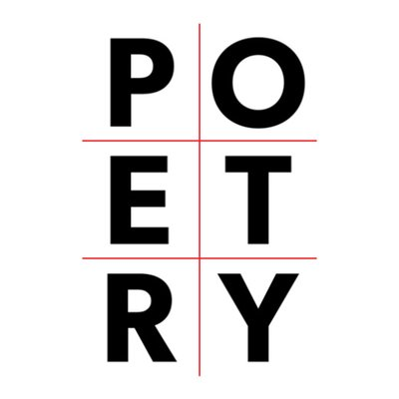
Poetry Analysis and Inquiry
Steps to analyzing poetry
- Read for feeling (read aloud)
- Reread and mark any questions you have with a “?”
  - Vocabulary?
  - Meaning?
- Read for meaning (do the following in any order)
  - Look for figurative devices and record on poem
  - Look for connotation- important in understanding poetry
  - Look for imagery (senses)
  - “translate” into your own words at the natural breaks
- Note title- how does it help with meaning or tone?
- What is the structure of the poem? Is it relevant to the meaning?
- Research the author’s biography
- Research the era in which it was written. Historical context is relevant to all writing.
Assignment:
- Read and analyze the poem (steps 1-4) with your group. Write all over the poem but leave room on the perimeter of the paper for more writing.
- Write a short biography of the author in a corner. Decide the relevant details.
- Summarize the poem’s meaning and tone under the poem. Use full sentences.
- Add images that illustrate the meaning. A talent in art is not necessary but showing meaning through colour and symbolism or metaphor is.
- Connect this poem to the world (Text-World). Explain the bigger picture of this poem. What current events does it address?
- These poems are sources for the questions below. On two corners of the paper, answer TWO of the following questions in point form or prose:
  - How does power affect relationships?
  - How can conflict lead to change?
  - What can influence an individual’s identity?
  - How can conflict influence an individual’s decisions and actions?

Assessment: each is worth 2 marks each except the last one Total /16
Below Target | Target | Exceeding Target
-Analysis is thorough and most devices are identified

-Poem is broken down into its meaning

-biography has relevant information to extend understanding of the poem

-Meaning of the poem is correct and insightful

- images are relevant and done neatly with colour

-Text to world is insightful and correct

-two inquiry questions are answered with detail and insight (4)

