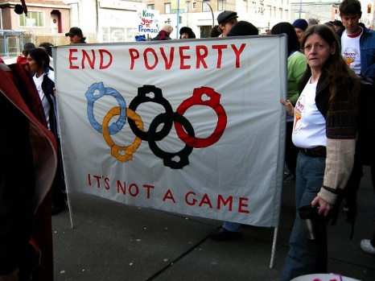
PhotoVoice
Photography can be a powerful tool for social justice.
Look at the following photographs:
- What do you see here?
- What is really happening here?
- How does this relate to our lives?
- Why does this situation, concern or strength exist?
- What can we do to improve this situation or to enhance these strengths?
From a photography “lens”, what makes these images so powerful?
- Composition
- Lighting creates mood
- Subject matter
- Perspective

To do:
By Thursday (?), I would like you to take a photo of an issue that concerns you about your community. The election is coming up and our government is chosen by the people who have concerns and/or interests in how we live our lives. Mr. Chan will be teaching you about the levels of government and its responsibility to the people.
You are going to take 1-3 photographs on your phone that will be your “photovoice”. What concerns you?
- Is it the homelessness in the neighborhood? The traffic? The pollution? The poverty? The closure of small business? Too few public transit options? Schools that need to be updated? More child care spaces??
On Thursday, you will present your photo to a small group of people who will ask you questions regarding intent and the image itself. Be ready to explain your thinking and intent.

