English 12
The aim of English Language Arts 12 is to provide students with opportunities for personal and intellectual growth through speaking, listening, reading, viewing, writing, and representing to make meaning of the world and to prepare them to participate effectively in all aspects of society.
The big ideas of English 12:
- The exploration of text and story deepens our understanding of diverse, complex ideas about identity, others and the free world
- People understand text differently depending on their worldviews and perspectives
- The examination of First Peoples cultures and lived experiences through text builds understanding of Canadian responsibilities in relation to Reconciliation
- Texts are socially, culturally, geographically, and historically constructed
- questioning what we hear, read, and view contributes to our ability to be educated and engaged citizens
- language shapes ideas and influences others

Content
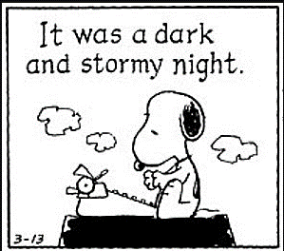
Prose: Short Stories, Lit Circles
Poetry: Traditional, Contemporary, Spoken Word
Drama: The Importance of Being Earnest (maybe) and/or One Act Plays
Inquiry: exploring the human experience through literature and media
Writing: Personal reflections and opinion pieces; formal paragraphs in response to literature, informal responses to literature, 2-3 types of essays such as persuasive, descriptive, narrative, and/or synthesis
Grammar and Vocabulary: The mechanics of good writing and building sophisticated vocabulary using mentor texts and online sites such as Grammar Bytes and No Red Ink

Edublog
Look under “Today’s Classes” to find the link to English 12 daily classes. If you are absent, don’t ask me what you missed, look on the blog and be ready for the daily lesson.

Assessment
Assessment will be both Formative (homework, informal feedback, suggestions, and conferences to help you learn) and Summative (to demonstrate what you have learned such as tests, projects, essays). Assessment will be based on skills, comprehension, depth and insight, and creativity.

Essays/projects/tests/assignments are worth 75% of the final mark.
Blog postings, reflections and essay corrections are worth 5% of your mark
There will be a Riverside English final exam at the end of the semester. This is worth 20% of your final mark.

Materials
Must bring everyday:
- Writing utensil (only blue or black pen or pencil) and highlighter
- Electronic device with a charger with the following files:
- English texts/books you have been assigned
- Access to your Edublog site is mandatory

