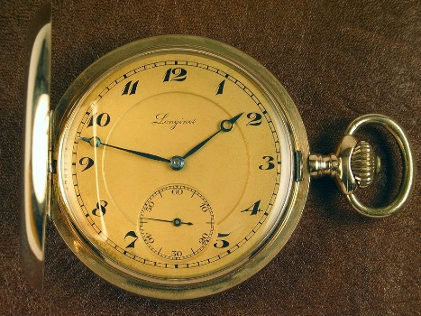
The Watch
“The Watch” was written by Elie Wiesel in 1964. The story is based on his personal experiences as a Hungarian Jew before and after the Holocaust. It focusses on the protagonist’s feelings of loss and trauma and his attempt to work through this pain through remembrance.
Vocabulary: Here are eight words in which you need to find the meaning. In YOUR OWN WORDS, what is the definition? You may use an image if you so choose.
- Bar Mitzvah-
- Kaftans-
- Ghettos-
- Torah
- Rabbi
- Shabbat
- Exhume
- usurpers
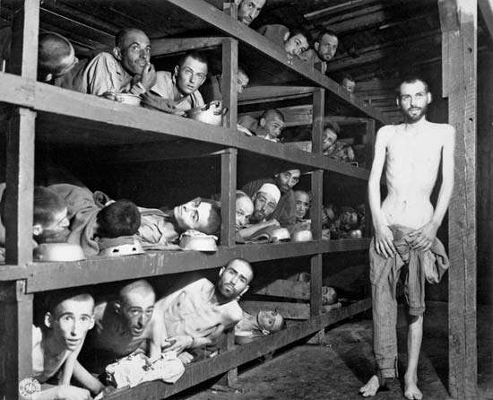
Prewriting: This photo (see blog) was taken by an American soldier five days after liberating the camp. One of the prisoners is the author of this story: Elie Wiesel. Write in first person point of view. You are to use imagery to describe what you feel, see, smell, hear and taste from EITHER THE POINT OF VIEW OF THE SOLDIERS OR AUTHOR.
Eg. My stomach rumbles.

As you read the story, highlight or underline the following on the story document:
- Rule of 3’s
- Sentence fluency
- Introductory commas
- Devices such as repetition, alliteration and imagery, verbal irony
To Record:
- What conflict is the main conflict in this story? Explain in a short paragraph.

- What does the watch symbolize? Explain.

- What is the point of view of the story and why is it relevant?

- Is the protagonist a static or dynamic character? Explain.

- Explain the end of the story. Why does he rebury the watch and walk away?

- The theme of this story is: (remember to list the topics first then put it into a universal message that you think the author was trying to say- no clichés and not specific to the characters or plot in the story)

- Inquiry question- researchable, within the scope of our study, not “yes” or “no”.

Post Writing:
Do you think the Jewish people should forgive the Nazi’s? Why or why not?
OR
How does one move on after such tragedy? If you were a counsellor, what would you suggest to Elie?

