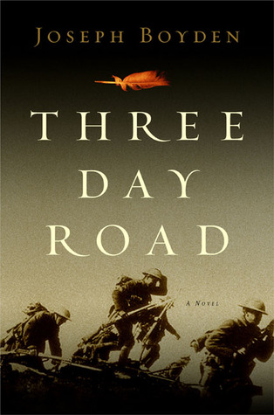
The Politics of Identity

Questions: Who has the right to claim an identity? Can an author write from a perspective of an identity that is not their own? Why or why not?

- Read chapter 1 and 2 of Three Day Road by Joseph Boyden.

- After reading these chapters, answer the following plot questions:

  - What is the setting of these two chapters? Years and location please.

  - The first section of the book (before chapter one) is possibly foreshadowing. What can you predict about the plot based on this section?

  - What are the physical and phycological effects of war on Xavier? Be detailed.

  - In three words each, how would you describe
    - The Aunt
    - Elijah
    - Xavier

- Read BOTH of the following articles:

https://www.theglobeandmail.com/news/national/giller-prize-winner-joseph-boydens-indigenous-ancestry-questioned/article33429989/

https://www.theglobeandmail.com/opinion/there-is-room-in-our-circle-for-joseph-boyden/article33467823/

- For ONE of the articles (you choose), you are to do the following:

  - Find three quotes from the article. Each one will be a
- Point of interest
- Point of value
- Point of question…… to you

  - You will respond to the quote, explaining your reasoning. Follow my formatting (quotation marks and italics for the quote) See my example below:

For example, the article “Heated Linguistic Debate” could be as follows:

Point of interest
“But by the mid-1980s, Mr. Chay had become aware of a shift in the language — of the growing sentiment that “Oriental” was geocentric, ethnocentric, and disparaging to Asians. It was a rhetorical tool of separation and otherness, he said.”

I did not realize why the term “Oriental” was not used anymore. I never thought of it; I just knew it was not politically correct. I realize now the term was meant to differentiate people of Asian descent from other Americans in an attempt to isolate as opposed to assimilate. I did some more research on this term and I learned it also includes people from the Middle East. The word “Oriental” means almost anyone East of Europe! That is a broad categorization.

Point of Value
“And, she said, the damage has been documented. A decade ago, the American Psychological Association recommended the immediate retirement of Native American mascots and symbols, in part because they appear ‘to have a negative impact on the self-esteem of American Indian children.’”

As a teacher, this information is valuable to me. It is important for all children to have a positive cultural/self-identity and if this study was done ten years ago, why are more teams not doing the right thing and changing their names?

Point of Question
“In addition, the poll — a survey of 504 people across the country — found that more than 70 percent of those questioned said they did not consider “redskin” to be disrespectful to Native Americans.”

I question who these 504 people are. Where do they live? Do they live on reserve or off reserve? I wonder how the polling company found these people because many may have been contacted by the Redskin Football franchise after they made the video to participate in the survey. I also question if these people knew the historical background of the name and why others were offended. Would it change their mind if they were more educated on the subject?

