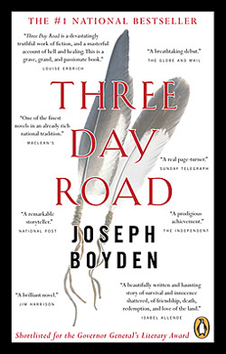
The Politics of Identity- Worksheet

Questions: Who has the right to claim an identity? Can an author write from a perspective of an identity that is not their own? Why or why not?

- After reading these chapters, answer the following plot questions:

  - What is the setting of these two chapters? Years and location please.

  - The first section of the book (before chapter one) is possibly foreshadowing. What can you predict about the plot based on this section?

  - What are the physical and phycological effects of war on Xavier? Be detailed.

  - In three words each, how would you describe
    - The Aunt

    - Elijah

    - Xavier

- For ONE of the articles (you choose), you are to do the following:

  - Find three quotes from the article. Each one will be a
- Point of interest
- Point of value
- Point of question…… to you

  - You will respond to the quote, explaining your reasoning. If you are confused, see my example on the reference sheet.
What article did you choose? Delete the one you did NOT do.

“Indigenous Ancestry Questioned” OR “Welcome in my circle”

Point of interest
Quote:

Explanation:

Point of Value
Quote:

Explanation:

Point of Question
Quote:

Explanation:

The final question:
Do you think Joseph Boyden should write stories about the Indigenous people of Canada? Why or why not? Post this final question on your blog. TAG: IdentityPolitics. Add an image!!

When you are done, email me this document. Subject line: Name, Identity Politics

