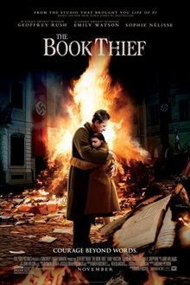
The Book Thief- movie
Before you watch the movie:
- Do a quick Google search on how the Nazi's treated Communists and where Communists were from.

- Do a quick Google search on Nazi book burning. Why did they burn books?

- Do a quick Google search on Kristallnacht. In sum, what was it?

- Do a quick Google search on the Hitler Youth. What were they? What did they do?

After the movie:
Choose ONE question to answer in a paragraph. Use the movie as your only source:
- How does one cope during hardship?
- What is the effect of racism on a person?
- How does one rebel against injustice?

