O Me! O Life!
By Walt Whitman
Oh me! Oh life! of the questions of these recurring,
Of the endless trains of the faithless, of cities fill’d with the foolish,
Of myself forever reproaching myself, (for who more foolish than I, and who more faithless?)
Of eyes that vainly crave the light, of the objects mean, of the struggle ever renew’d,
Of the poor results of all, of the plodding and sordid crowds I see around me,
Of the empty and useless years of the rest, with the rest me intertwined,
The question, O me! so sad, recurring—What good amid these, O me, O life?

Answer.
That you are here—that life exists and identity,
That the powerful play goes on, and you may contribute a verse.
(written in 1892)

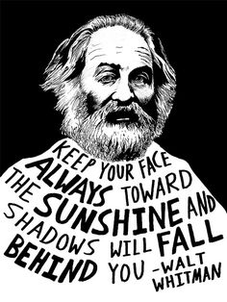
Find the following figurative devices and label on the poem:
- Metaphors
- Apostrophe
- Symbolism
- allusion
Find the following lyrical devices:
- Alliteration
- Consonance
- assonance
What is the structure of this poem?

What is the tone of this poem? (Hint: it changes)

What is the literal meaning of this poem?

Why does Mr. Keating quote this poem? What was his intent?

